# Lec 4 Spyder Test

No amp

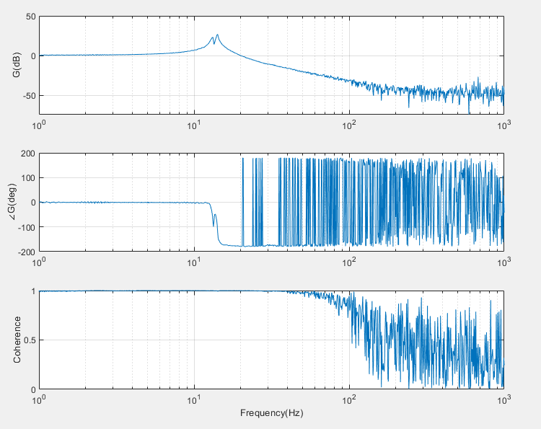

No amp

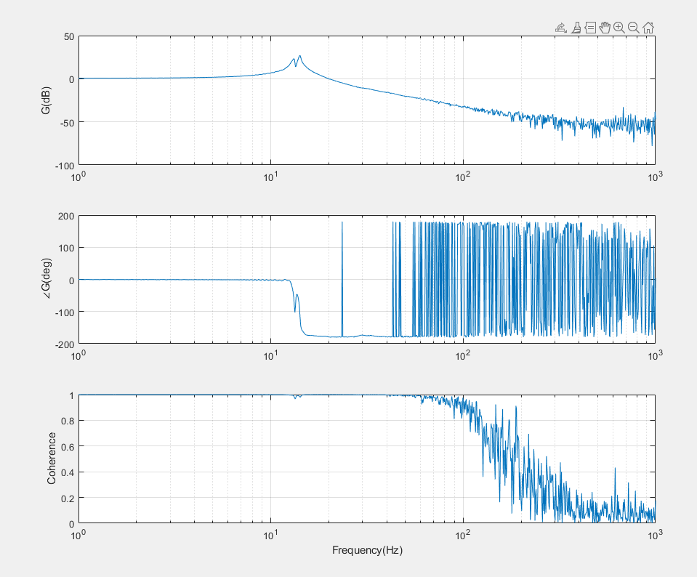

1e3 supposeldy

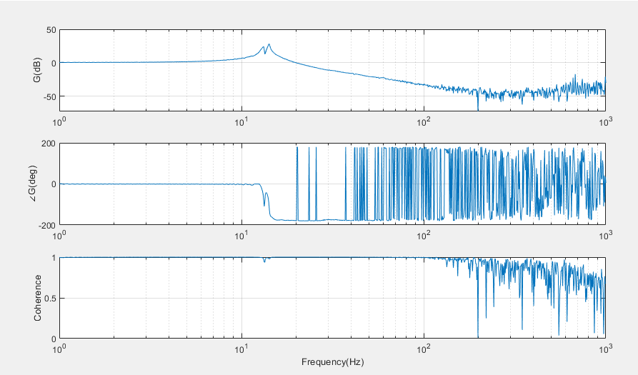

% ----- Parameters -----

amp_min = 1; % amplitude at start of ramp

amp_max = 1e2; % amplitude at end of ramp

ramp_start_frac = 0.3; % fraction of vector where ramp starts (30%)

% ----------------------

N = length(in);

% Define ramp start and end indices

start_idx = floor(ramp_start_frac * N); % start of ramp

end_idx = N; % end of ramp

% Initialize amplitude vector

amp = ones(N,1) * amp_min; % default amplitude = amp_min

% Logarithmic ramp

ramp_len = end_idx - start_idx + 1;

ramp_idx = 0:(ramp_len-1); % indices for ramp

amp_ramp = 10.^( log10(amp_min) + (log10(amp_max)-log10(amp_min)) * (ramp_idx/(ramp_len-1)) );

% Apply ramp

amp(start_idx:end_idx) = amp_ramp;

% Scale input

in_scaled = in .* amp;

% Optional: plot amplitude envelope

figure;

plot(amp);

xlabel('Sample index'); ylabel('Amplitude multiplier');

title('Logarithmic Amplitude Ramp');

grid on;

# Chirp

## tmax = 1s, ts = 30e6 =

#### 1 Hz to 10 kHz (10e4)

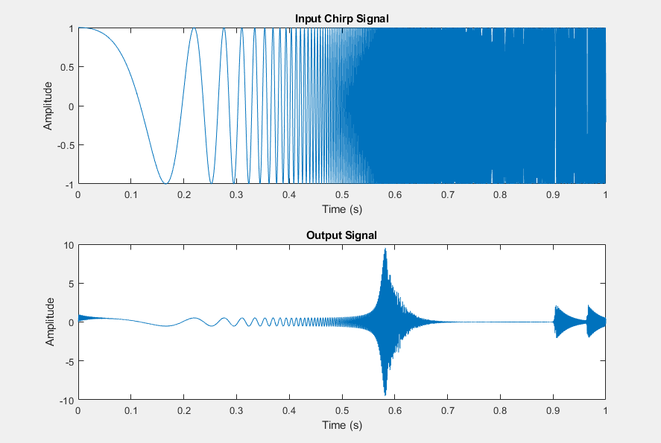

#### 1 Hz to 100 kHz (10e5)

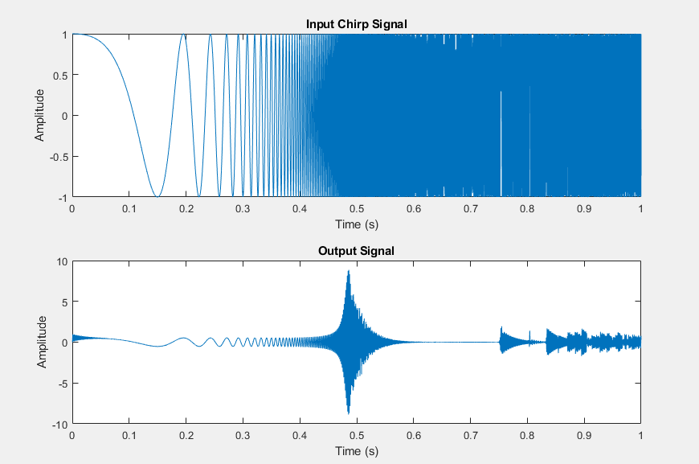

#### 1 Hz to 1 MHz (10e6)

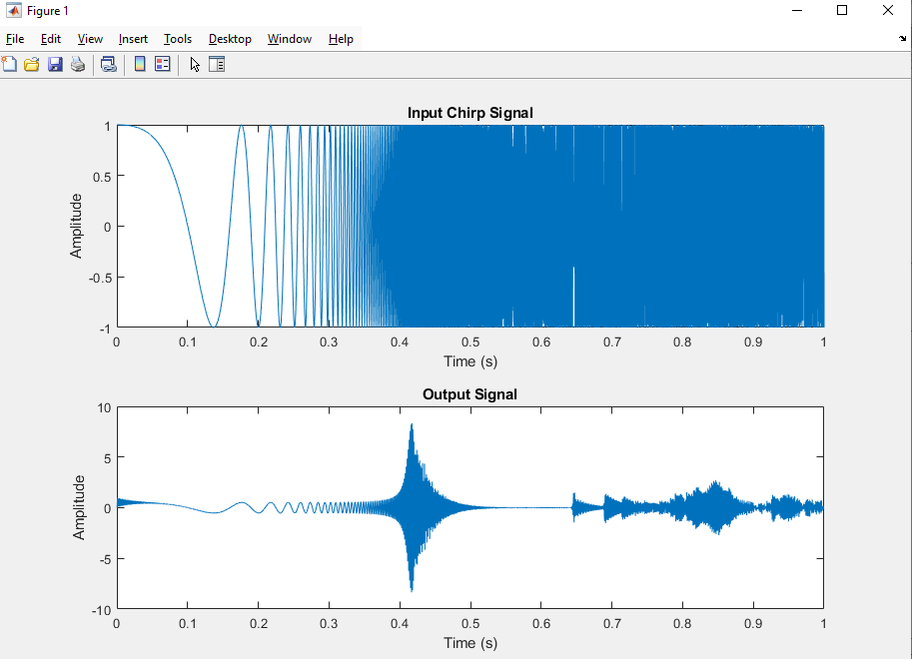

## Testing time

Tmax = 1s



Tmax = 10s

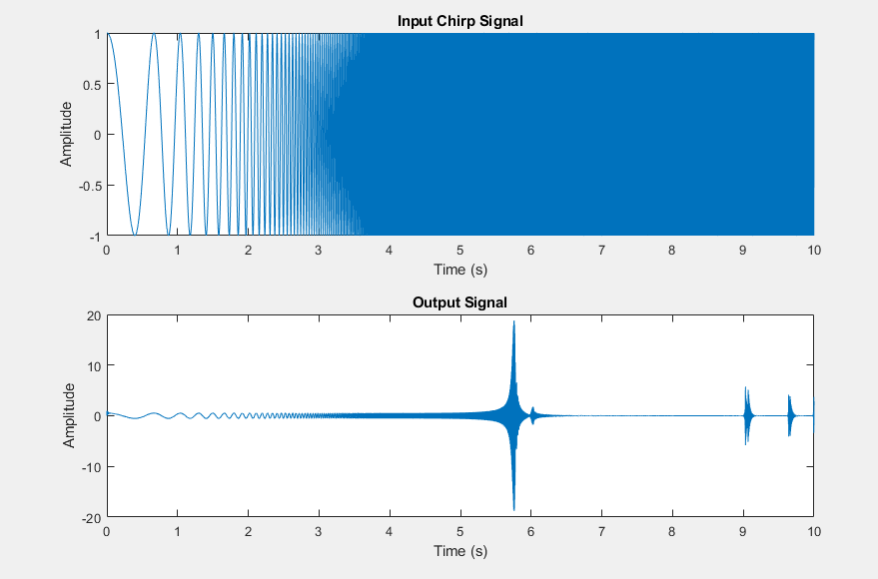

### 1Hz to 10 kHz, fs = 10*fmax, tmax = 30s

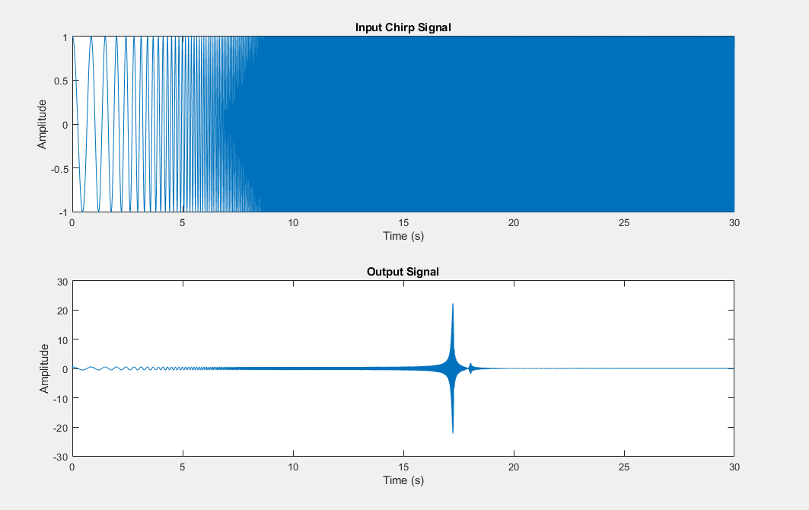

(tfestimate didn’t compute, probably too much information)

looks like no meaningful information for first 15s or so, can probably start from higher than 1hz

### 10 Hz to 10 kHz, fs = 10*fmax, tmax = 30s

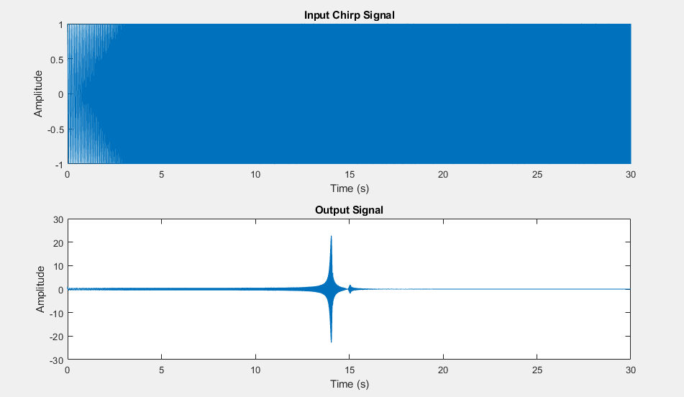

(still no bode plot)

### 10 Hz to 1 kHz, tmax = 5s (try to get it to run)

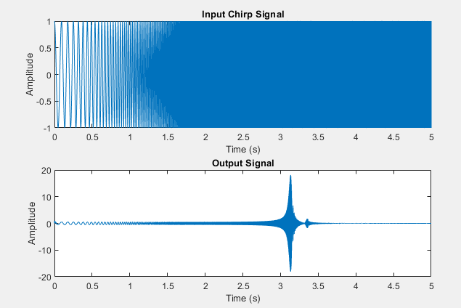

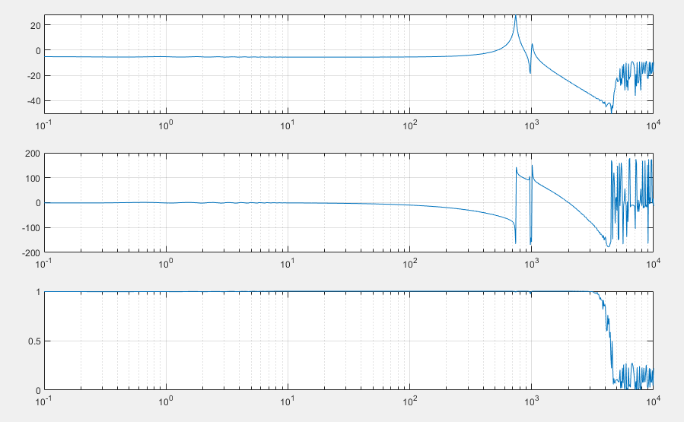

Finally bode plot generates within <20s

### 10 Hz to 10 kHz, tmax = 5s (GOOD)

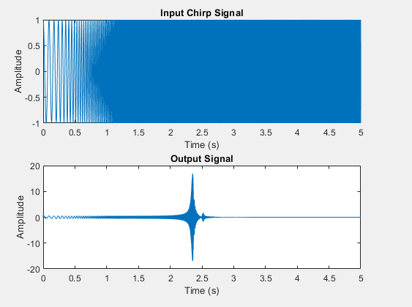

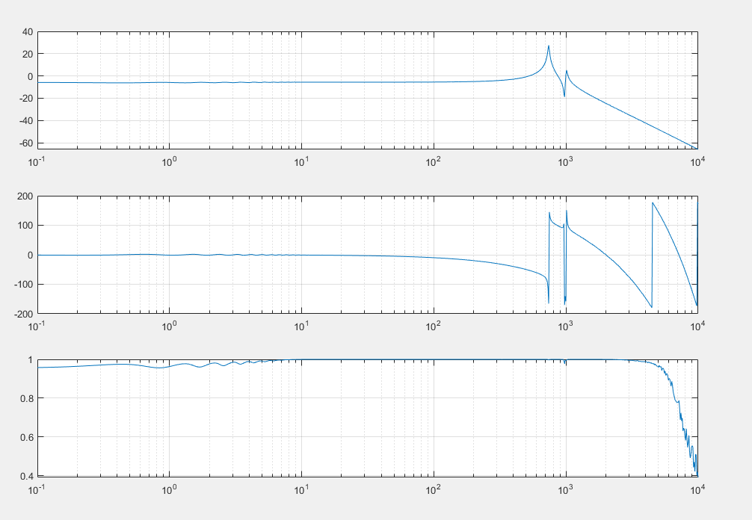

(took ~1min to solve but we got there)

### 100 Hz to 10 kHz, tmax = 5s ; tfestimate(2,4)

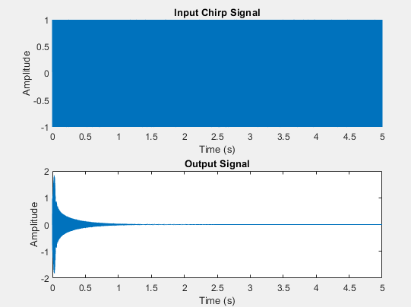

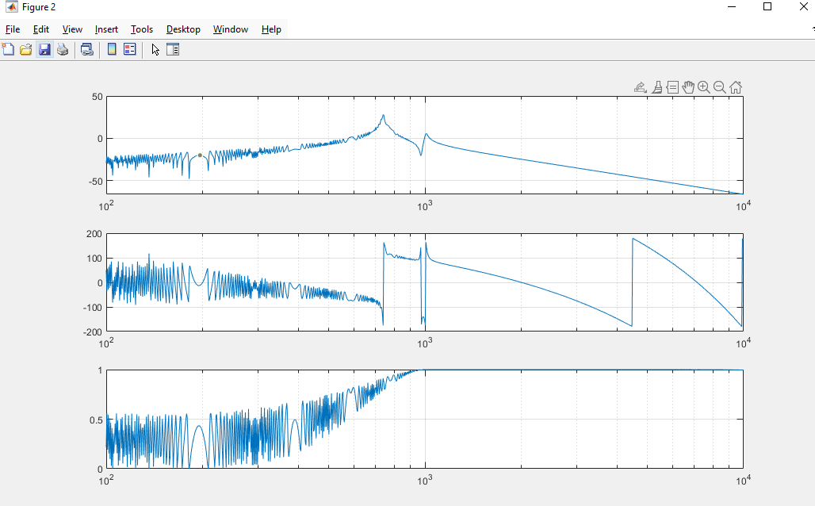

Took ~2min to compute

Complete garbage, so lets stick to 10Hz minimum lol

### 10 Hz to 10 kHz, tmax = 5s ; tfestimate(1,4)

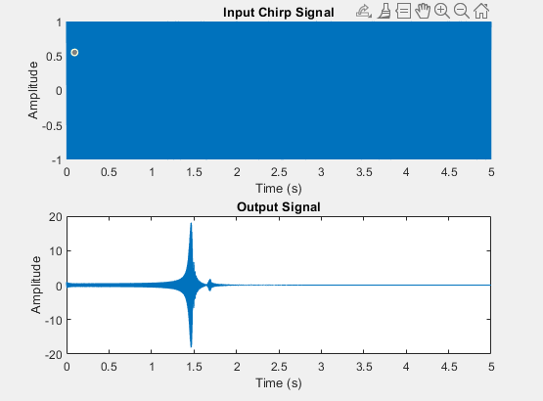

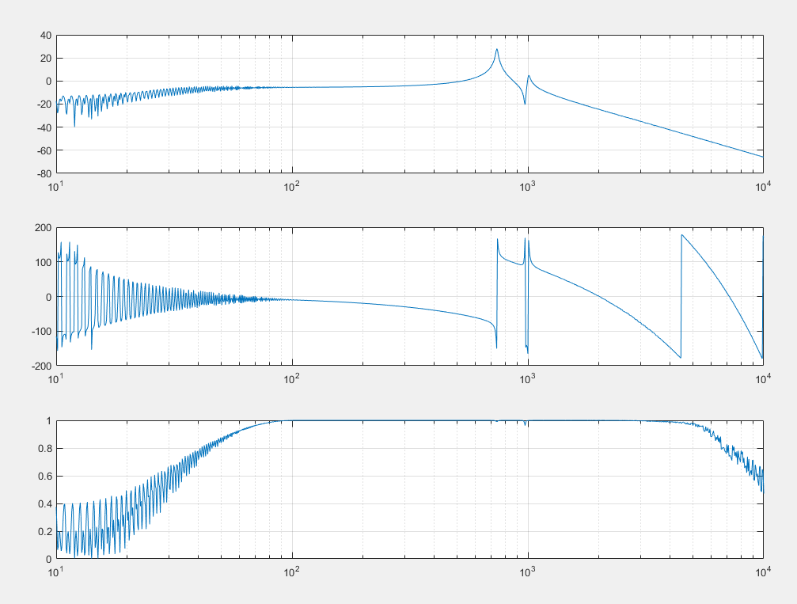

This is kinda cooked so we should keep tfestimate(-1,4)

### 10 Hz to 100 kHz, tmax = 5s ; tfestimate(-1,5)

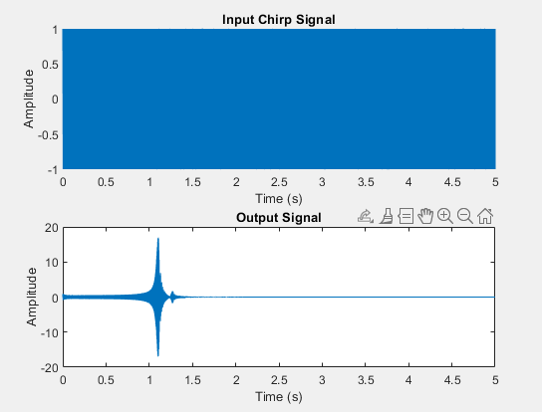

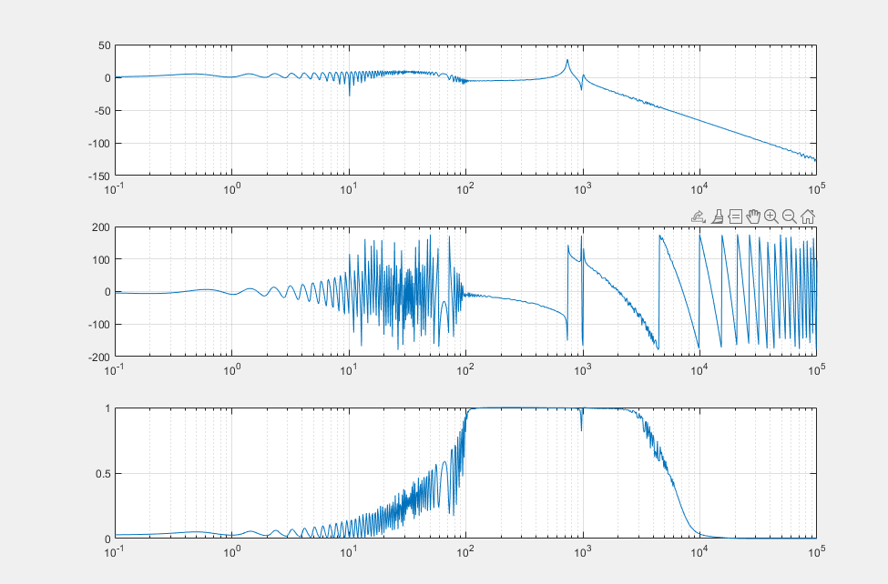

Took like 30mins to compute and it’s garbage, so probably stick to 10^4

### (bad) 10 Hz to 10 kHz, tmax = 5, tfestimate(-1,4)

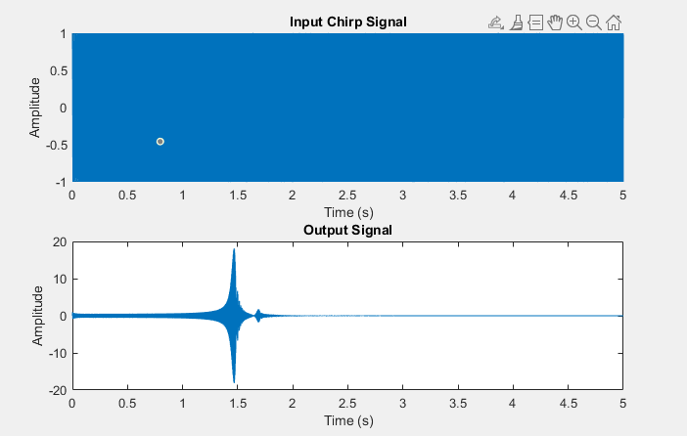

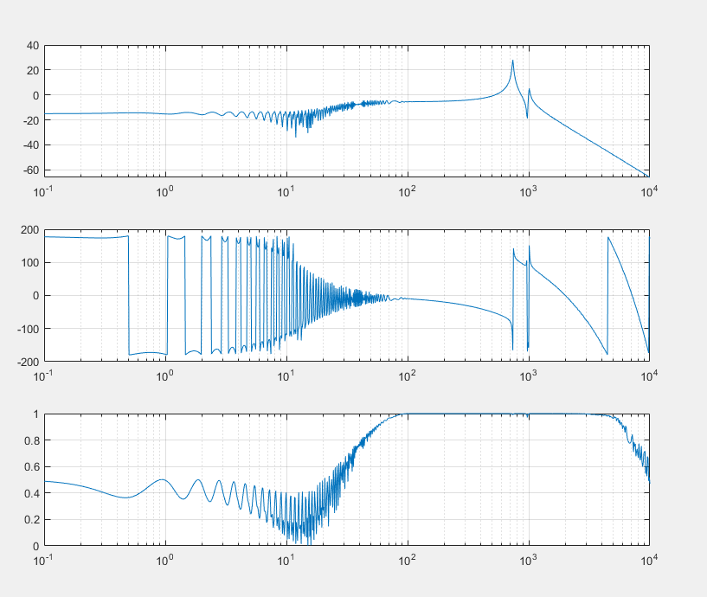

### 1 to 10e4, tmax = 5, tfestimate(-1,4)

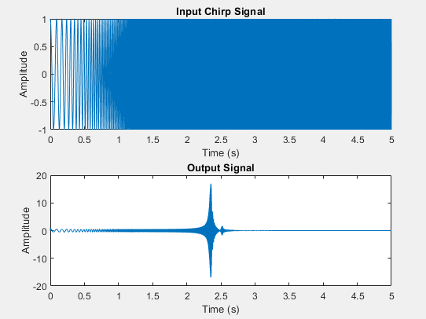

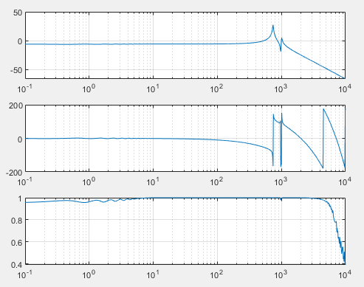

### 10 to 1e4, tmax = 5, tfestimate(-1,4)

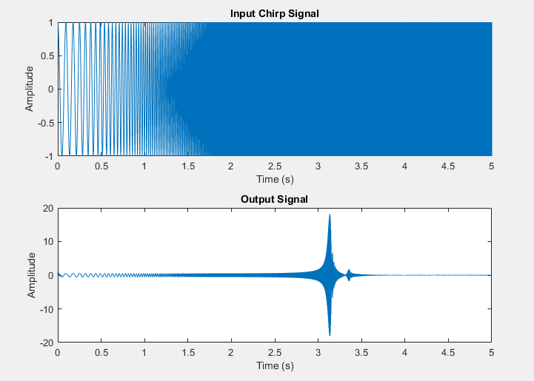

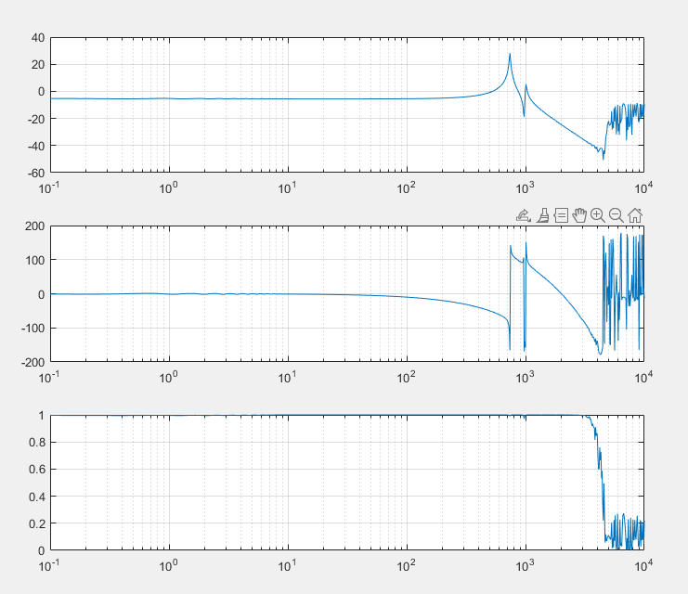

20s to compile

### 10 to 1e4, tmax = 5, tfestimate(1,4)

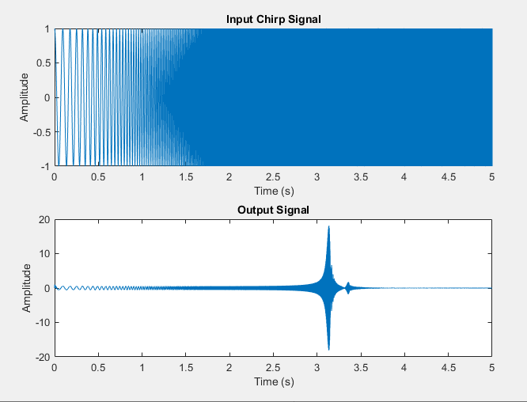

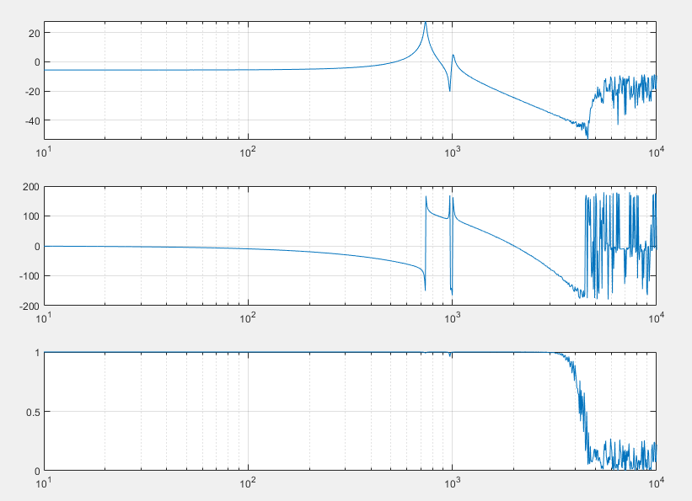

## Playing with scaling input

### 10 to 1e4, tmax = 5, tfestimate(1,4), hard 10x (1e3 to 1e4)

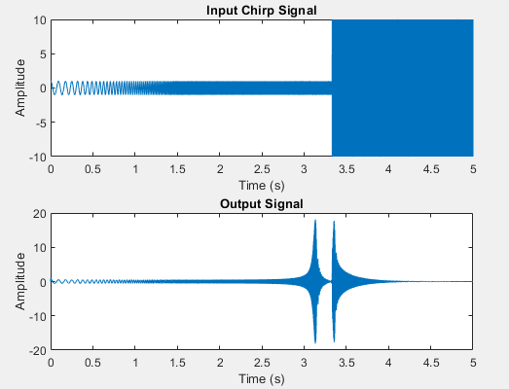

Definitely bad

### 10 to 1e4, tmax = 5, tfestimate(1,4), linear 10x (1e3 to 1e4)

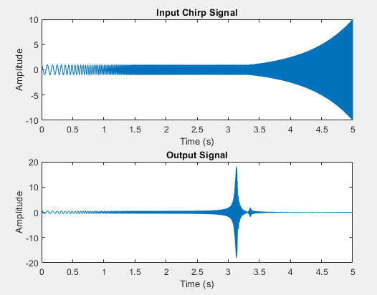

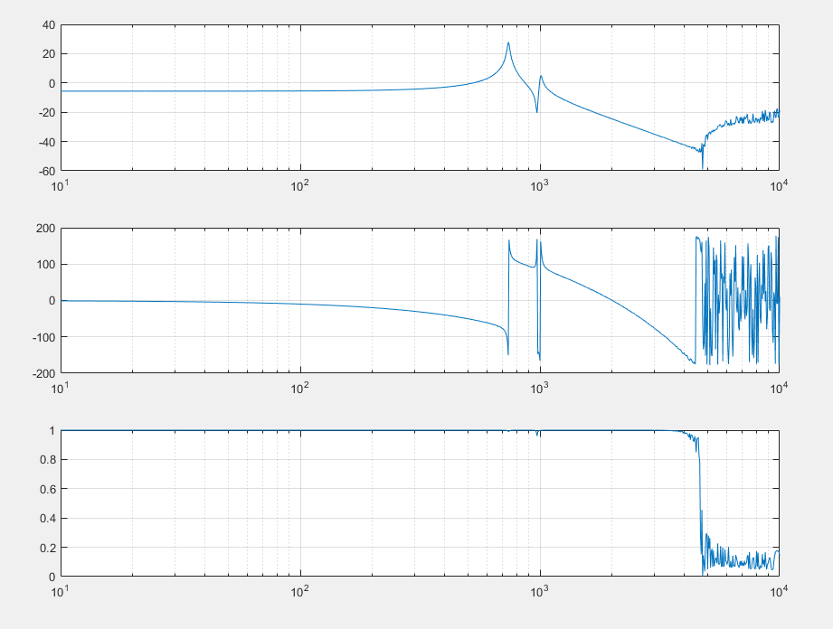

### 10 to 1e4, tmax = 5, tfestimate(1,4), log 10x (1e3 to 1e4)

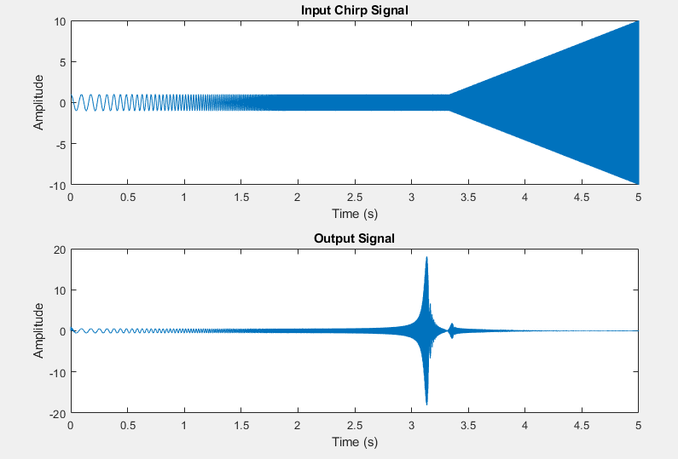

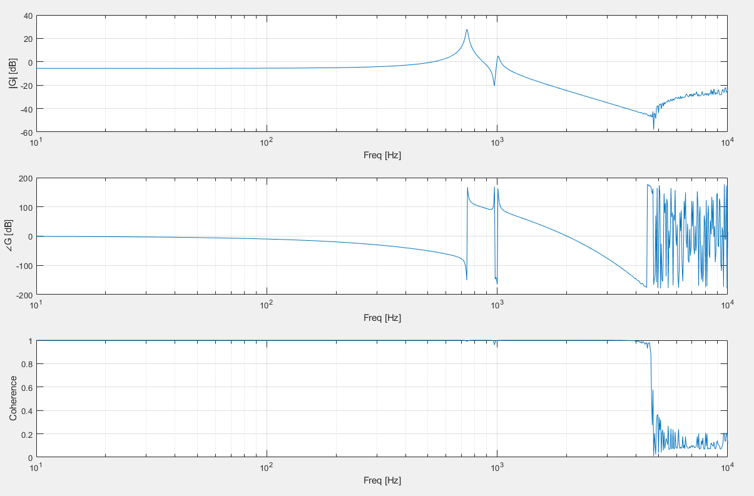

### 10 to 1e4, tmax = 5, tfestimate(1,4), log 100x (1e3 to 1e4)

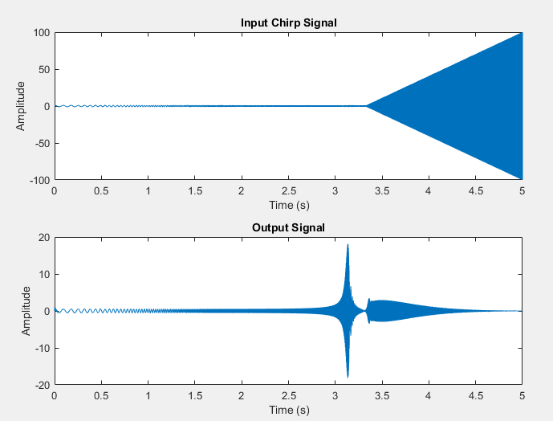

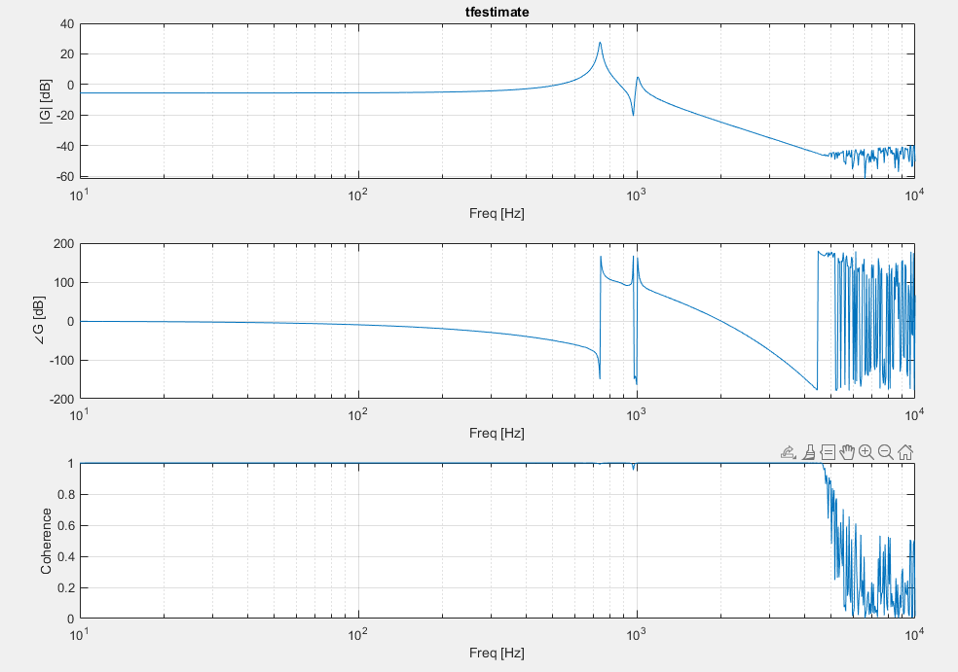

### 10 to 1e4, tmax = 5, tfestimate(1,4), log 100x (2e3 to 1e4)

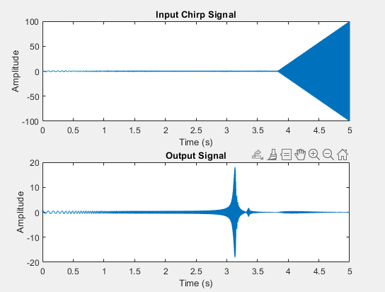

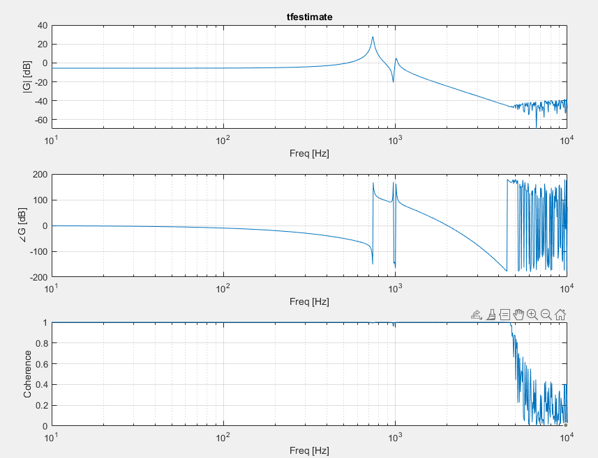

### 10 to 1e4, tmax = 5, tfestimate(1,4), log 1000x (2e3 to 1e4)

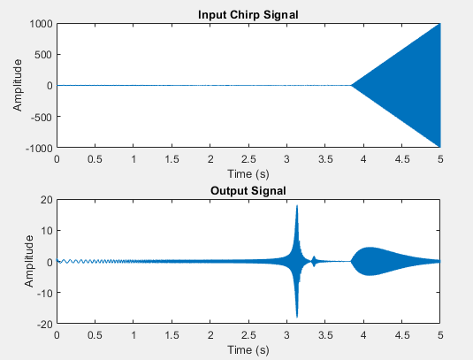

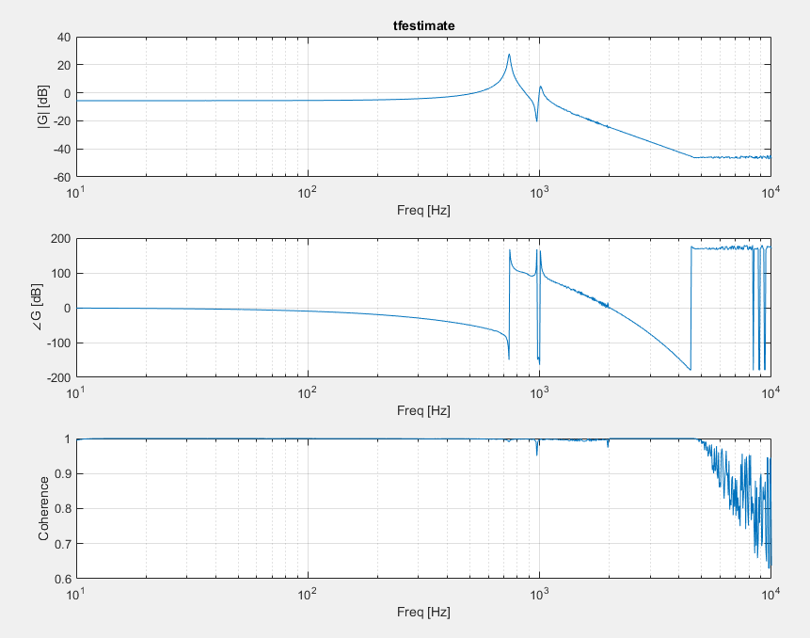

### 10 to 1e4, tmax = 5, tfestimate(1,4), log 1e4 (2e3 to 1e4)

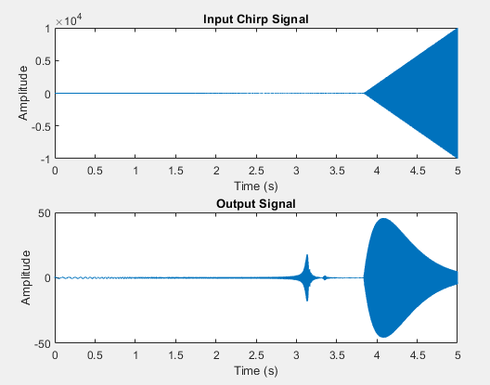

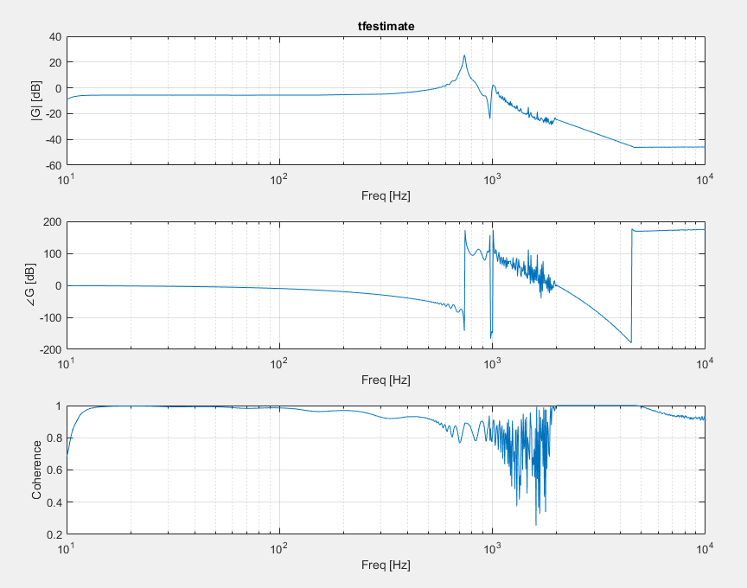

Uhhh wtf

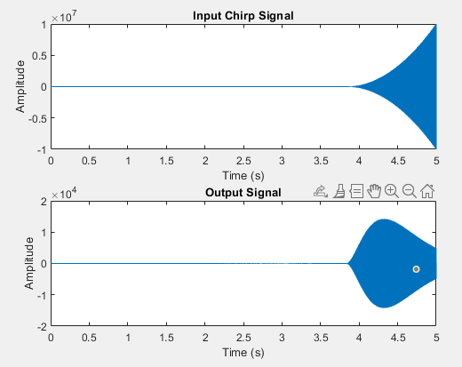

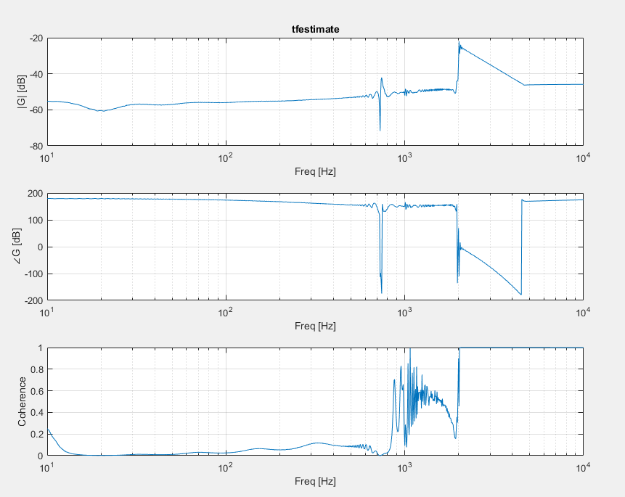

### 10 to 1e4, tmax = 5, tfestimate(1,4), log 1e3 (3e3 to 1e4)

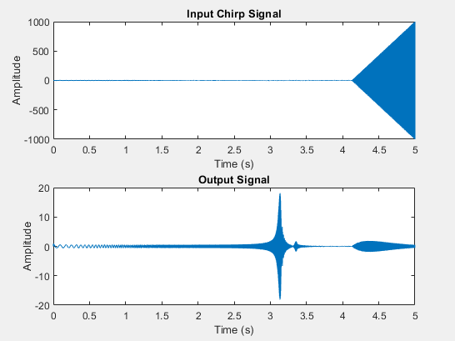

### A screenshot of a graph AI-generated content may be incorrect.10 to 1e4, tmax = 5, tfestimate(1,4), log 1e4 (3e3 to 1e4)

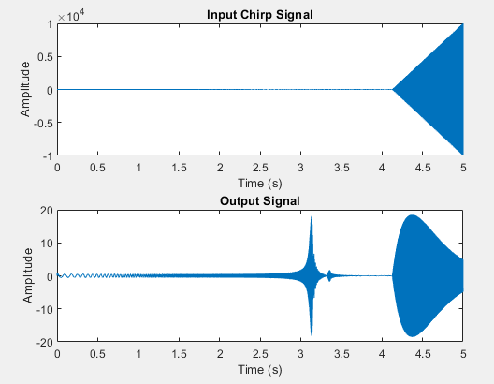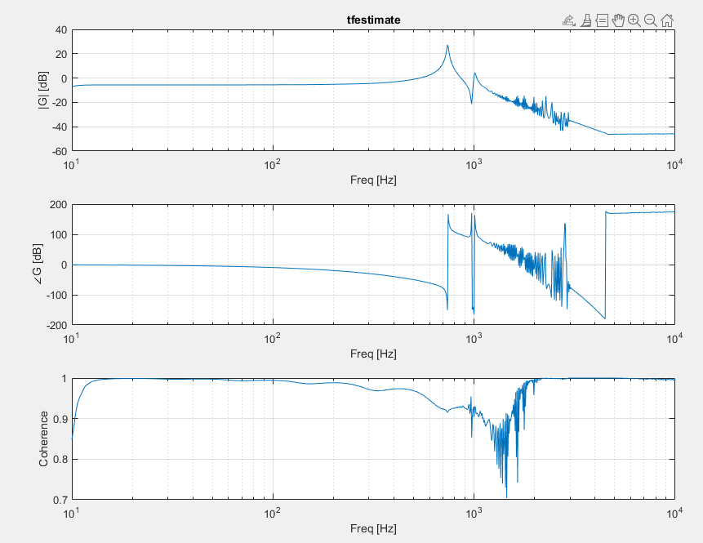

### 10 to 1e5, tmax = 5, tfestimate(1,5), log 1e3 (2e3 to 1e4)

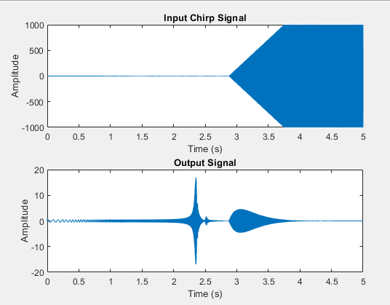

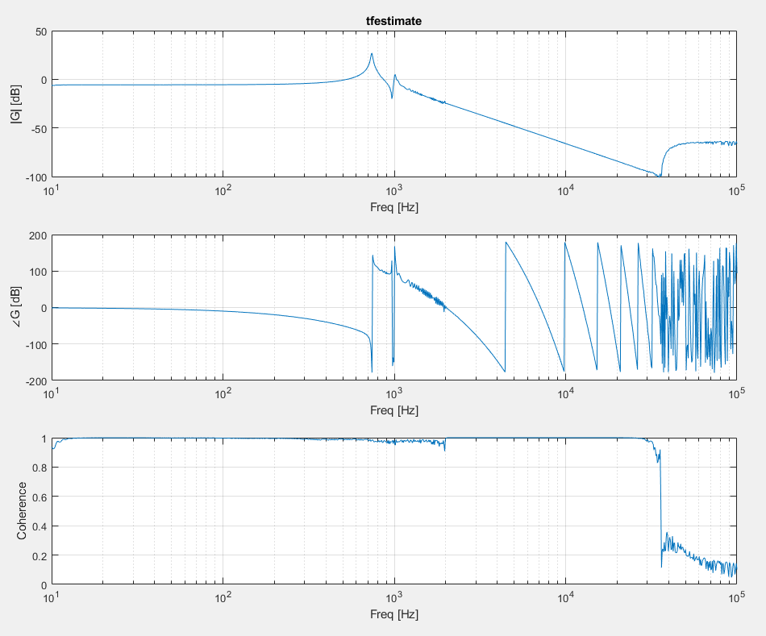

(took maybe 2mins)

### 10 to 1e5, tmax = 5, tfestimate(1,5), log 1e4 (2e3 to 1e5)

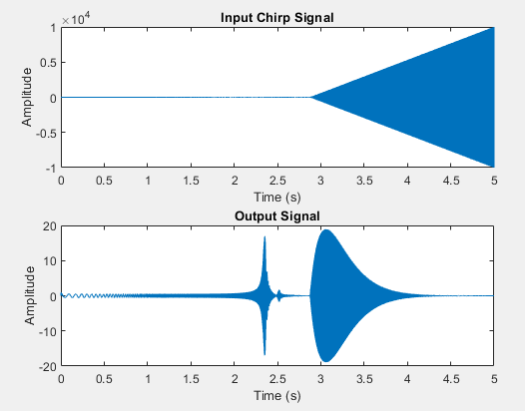

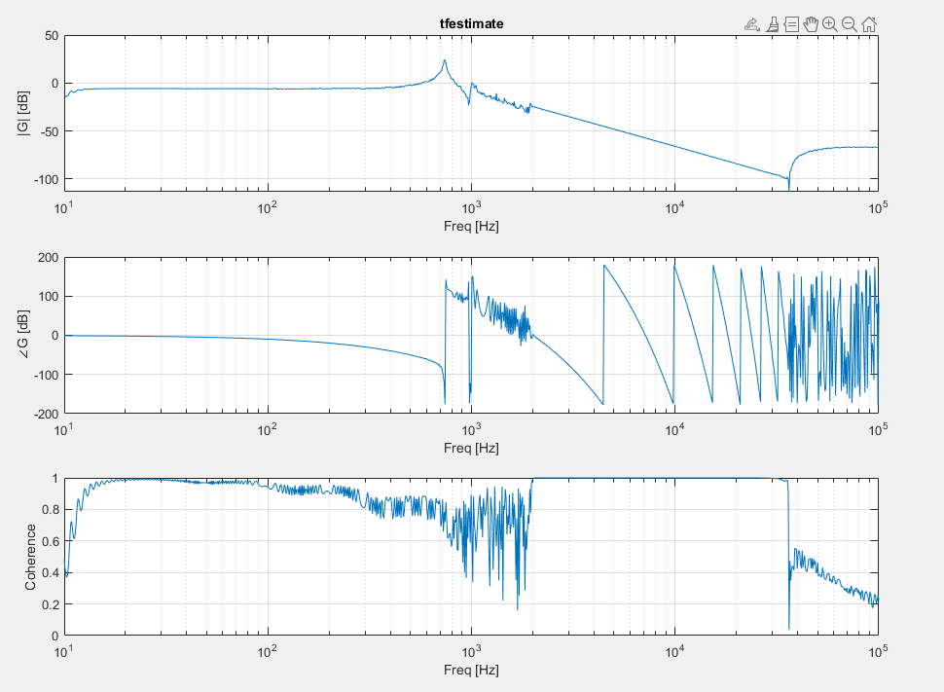(3.5 minutes for this garbage)

## Sample Time

### 10 to 1e4, 10s, log 1e3 (2e3 to 1e4)

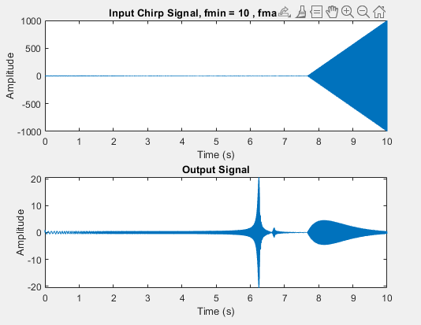

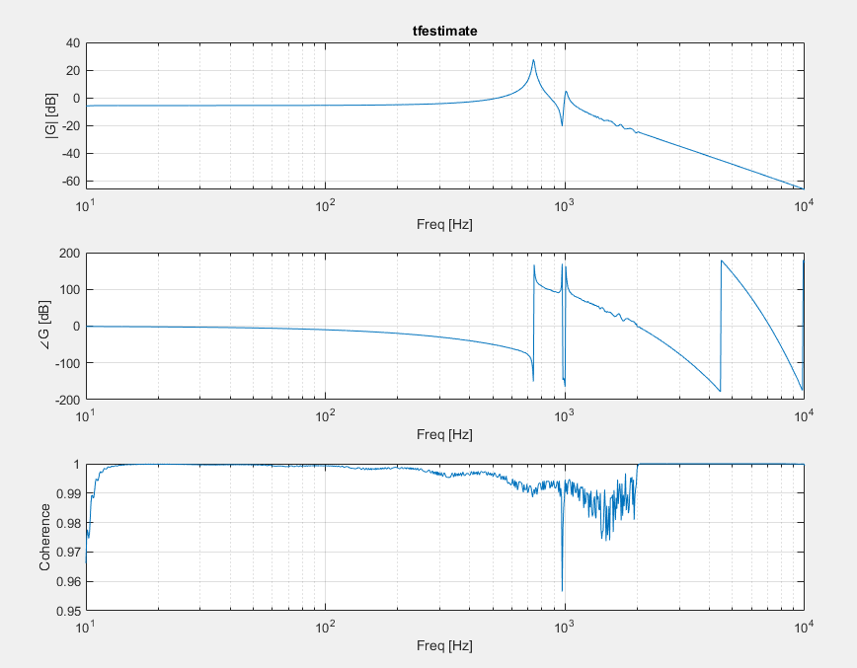

### 10 to 1e4, 10s, log 1e3 (1e3 to 1e4)

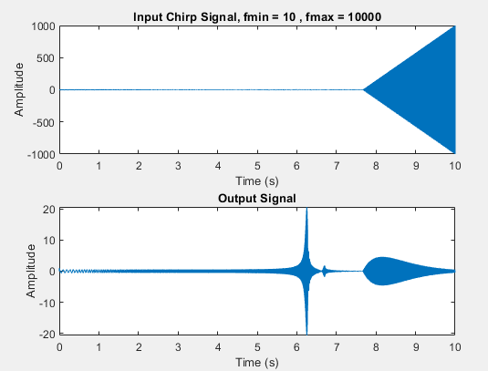

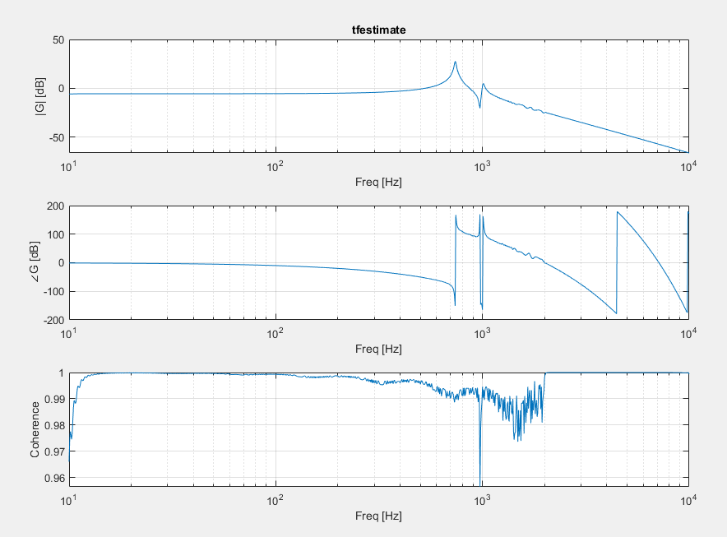

### 10 to 1e4, 10s, no scaling

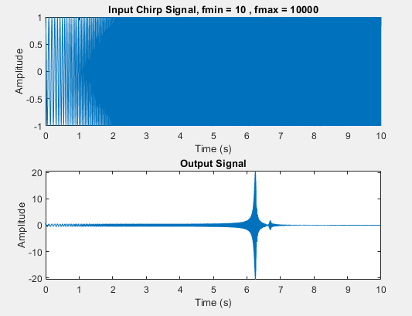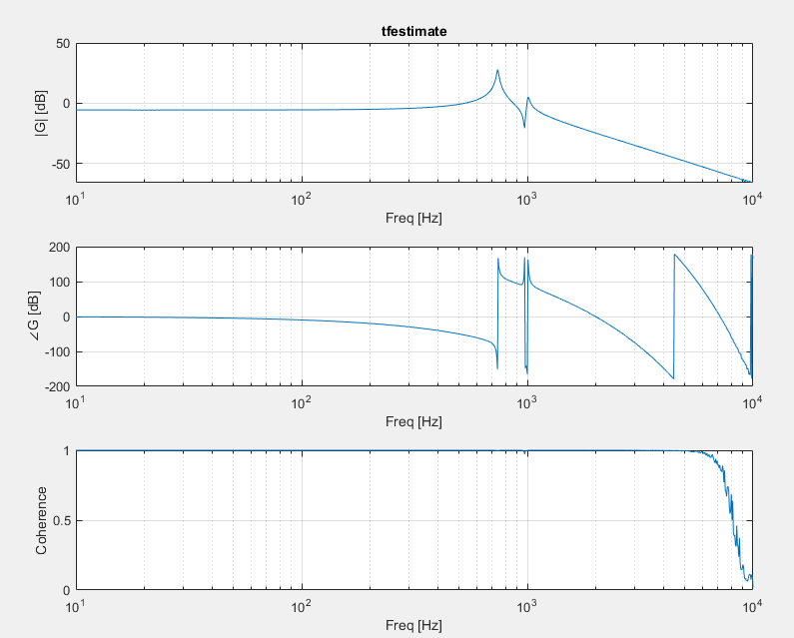

### 10 to 1e4, 10s, log 1e1 (2e3 to 1e4)

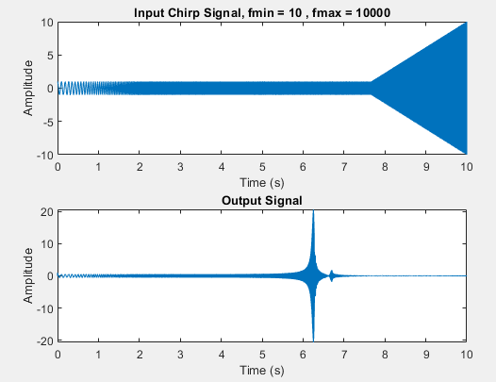

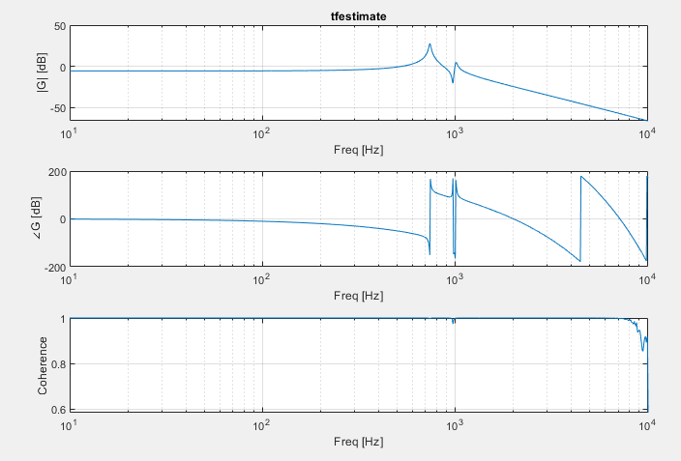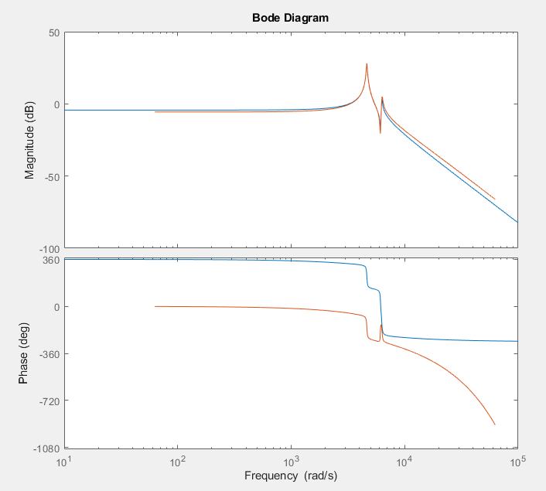

### 10 to 1e4, 10s, log 1e2 (2e3 to 1e4)

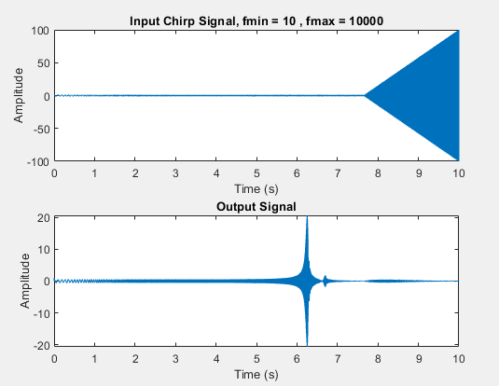

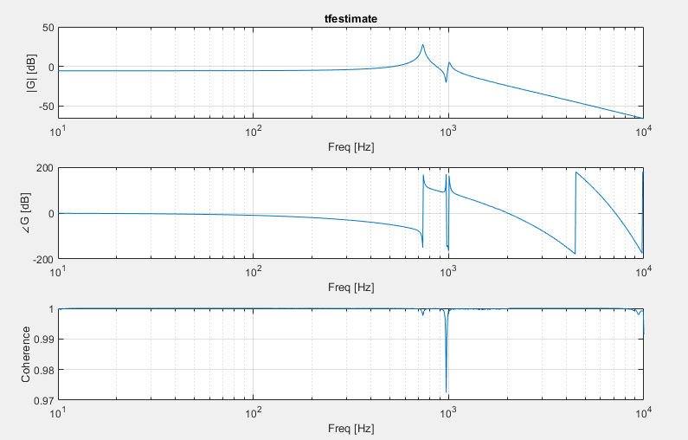

### 10 to 1e5, 10s, log 1e2 (2e3 to 1e4)

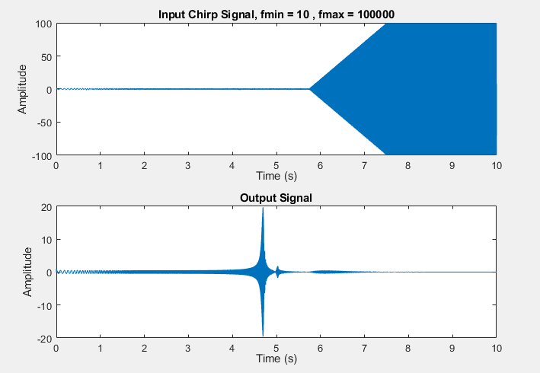

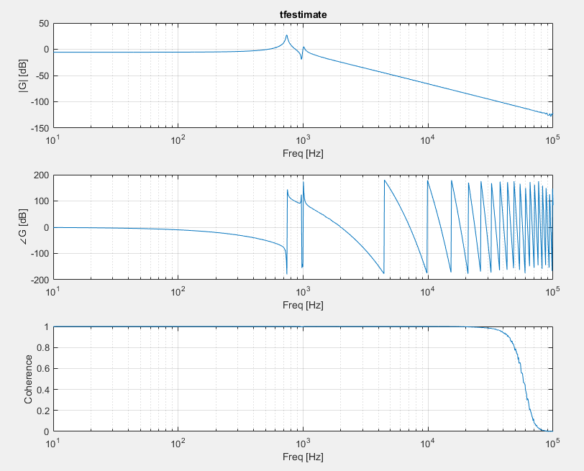

Unlikely that there are modes past 1e4

Frd

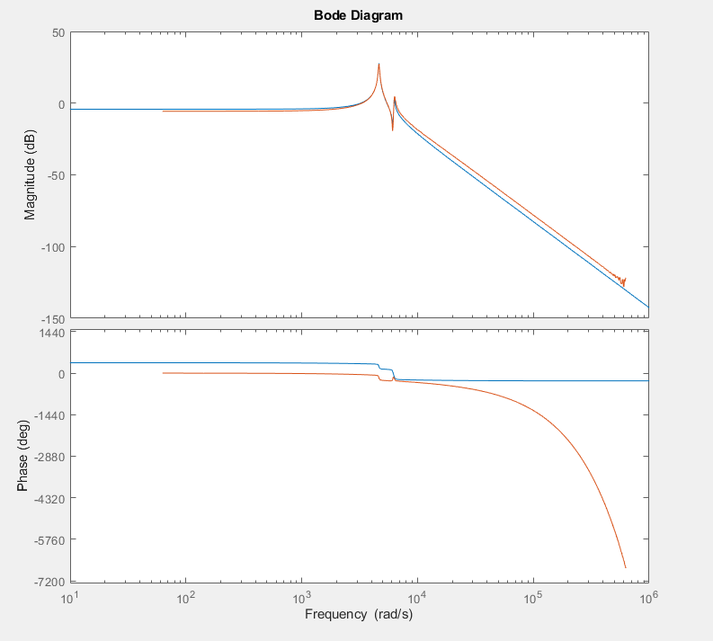

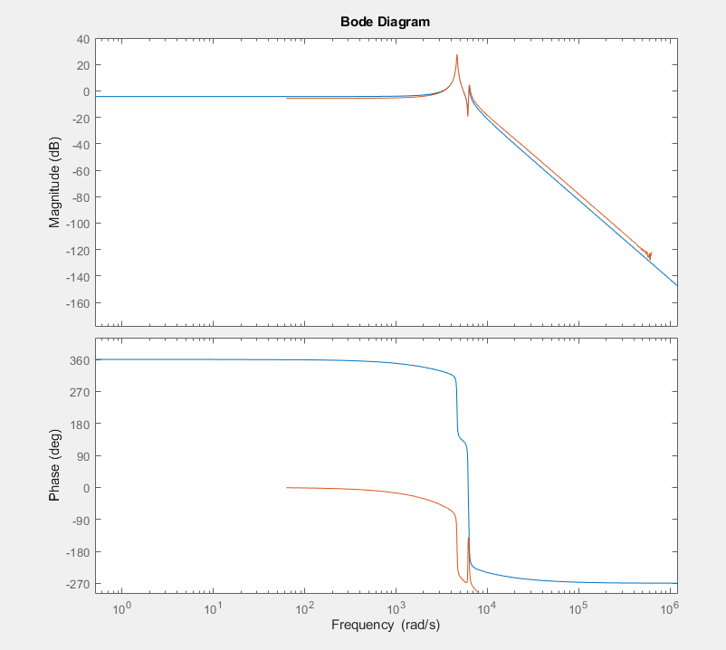

## Windowing Chirp

### No scaling

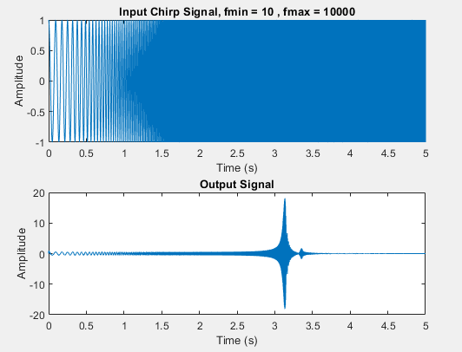

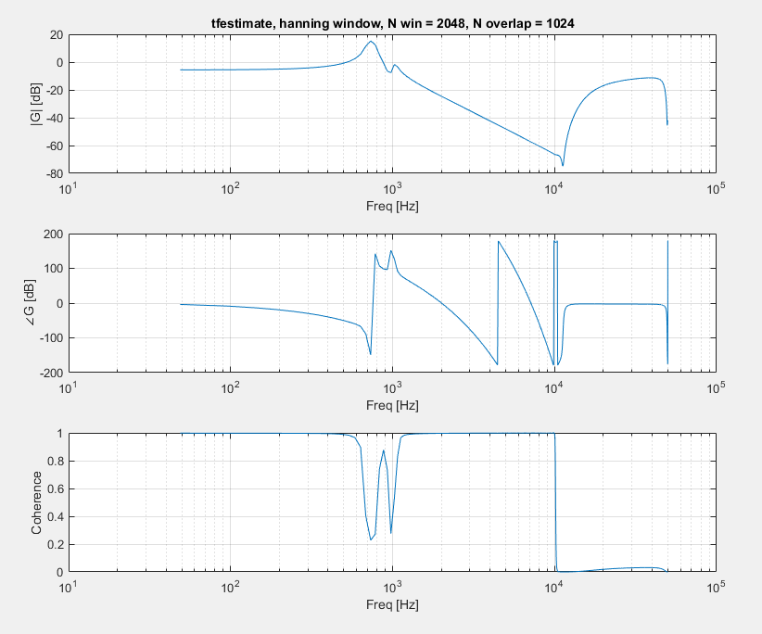

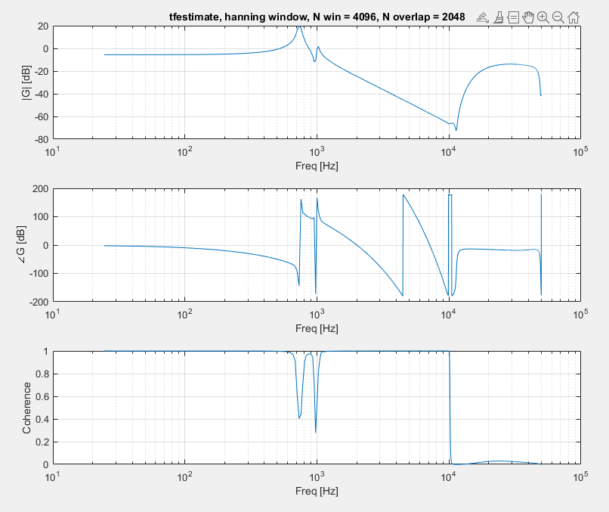

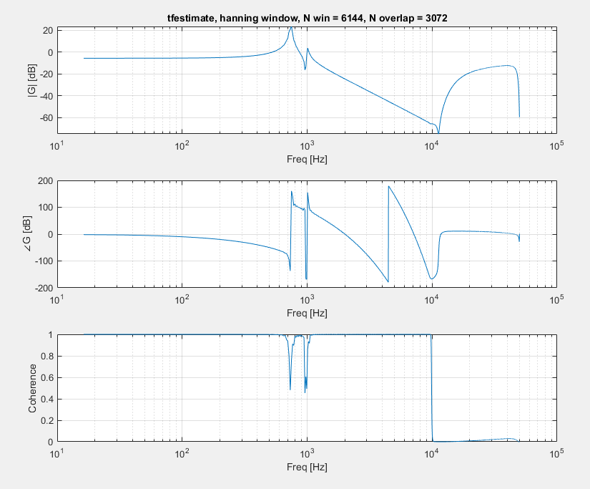

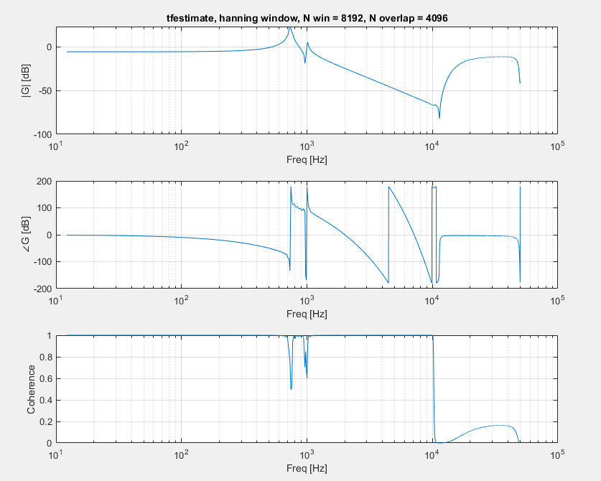

### 10 to 1e4, tmax = 5, log 1e3 (2e3 to 1e4)

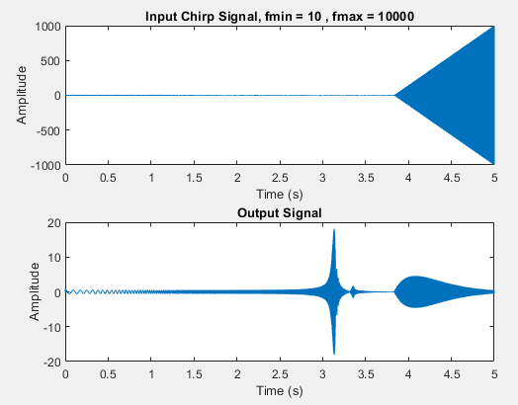

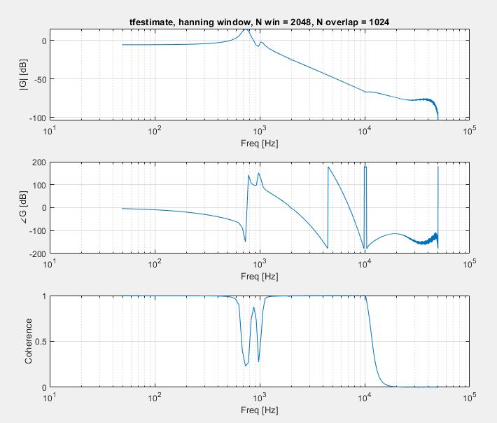

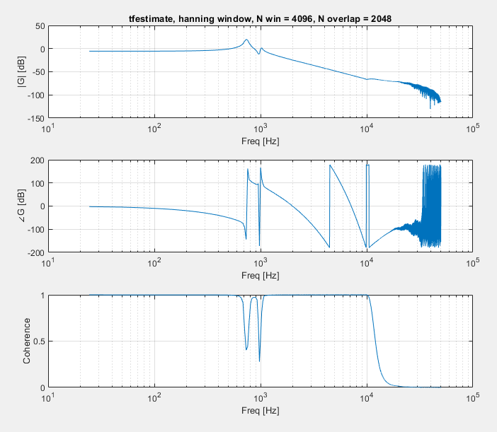

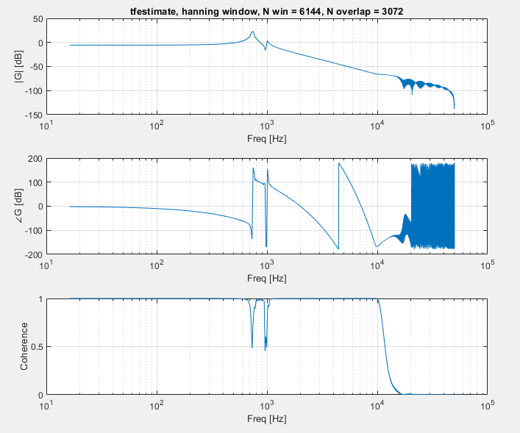

### 10 to 1e5, tmax = 5, log 1e3 (2e3 to 1e4)

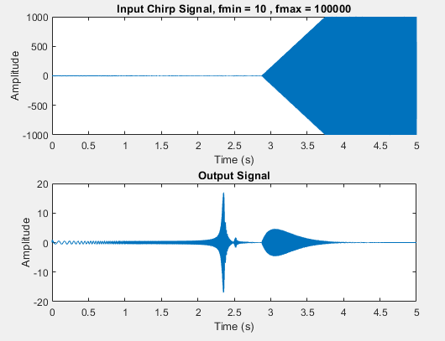

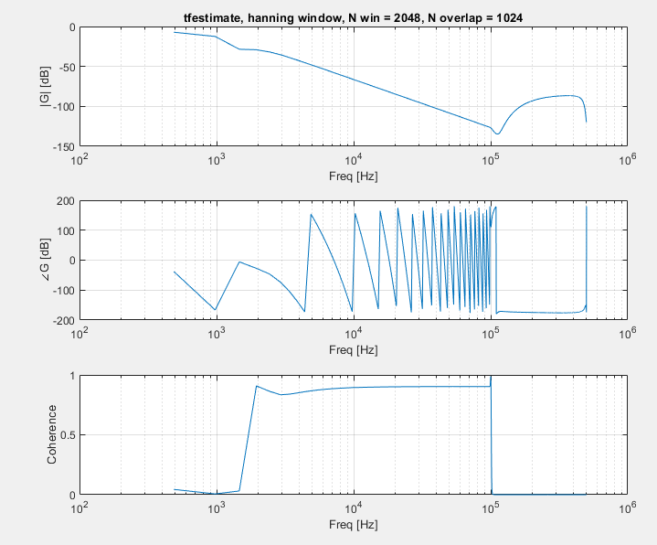

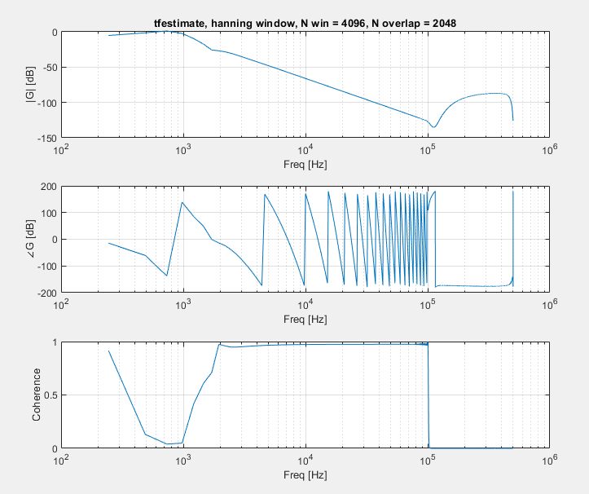

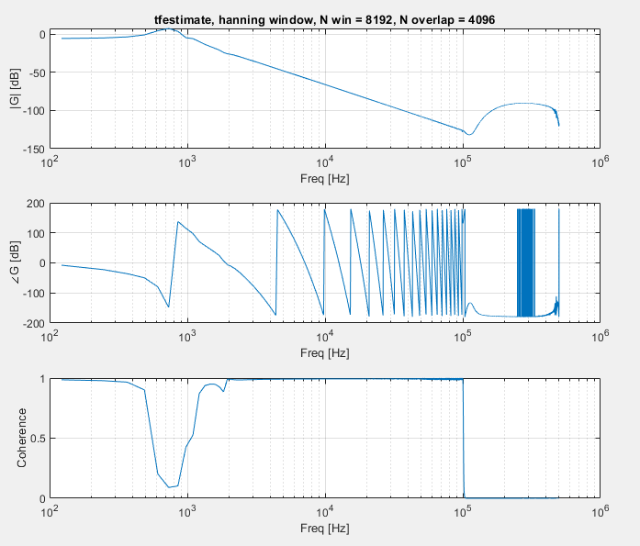

### Hanning window (don’t use)

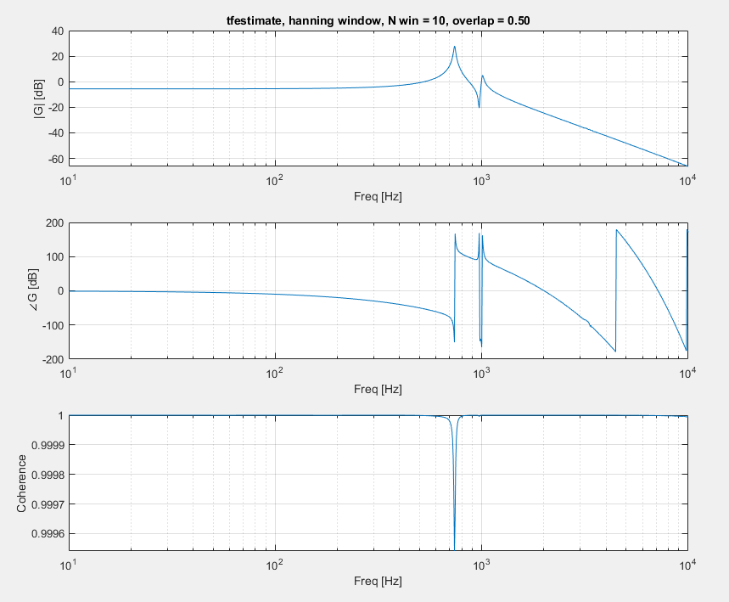

### Rectangular window

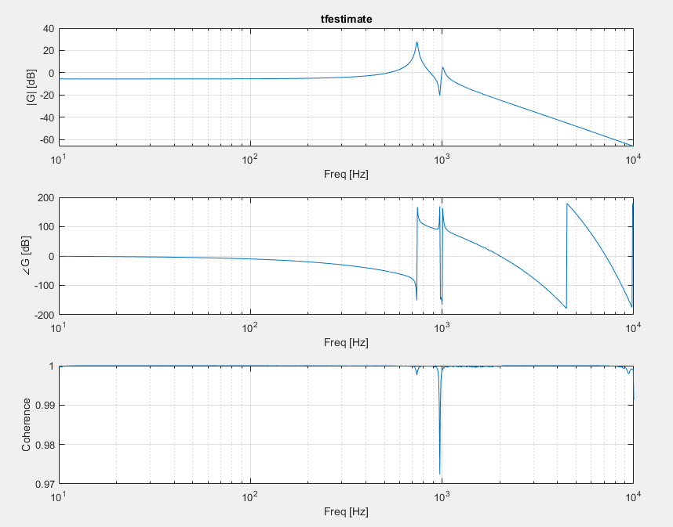

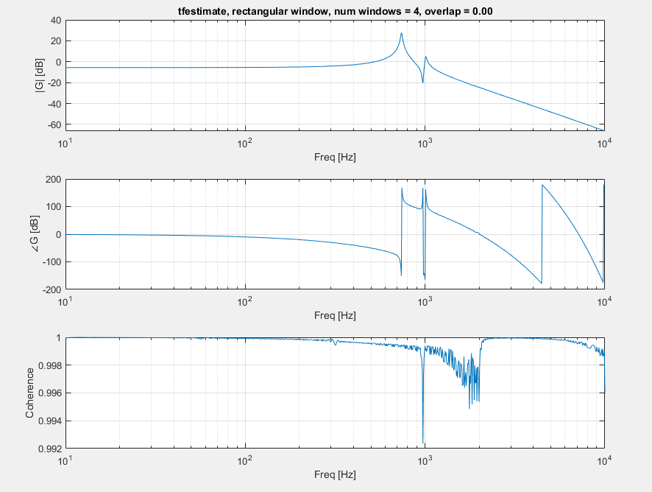

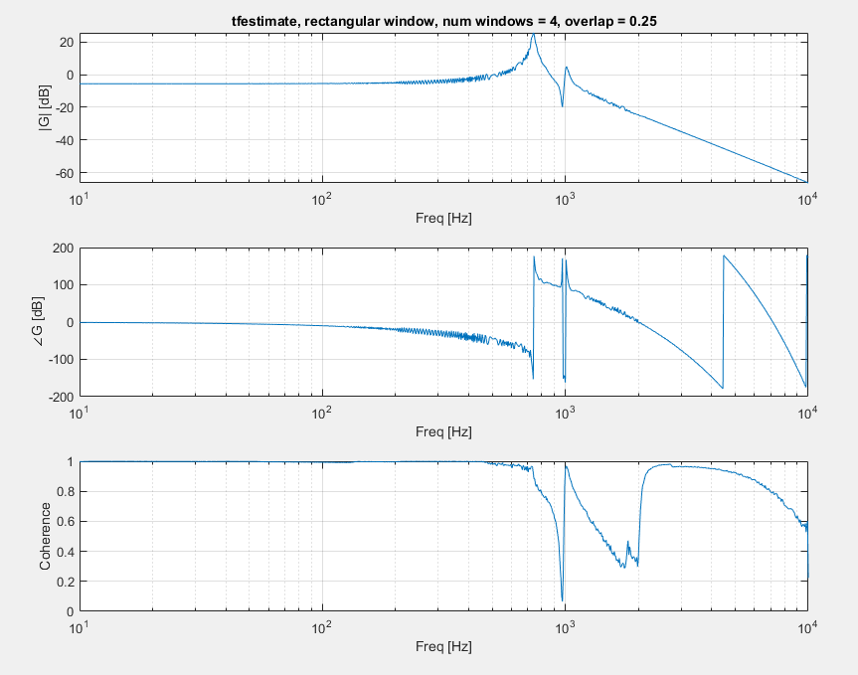

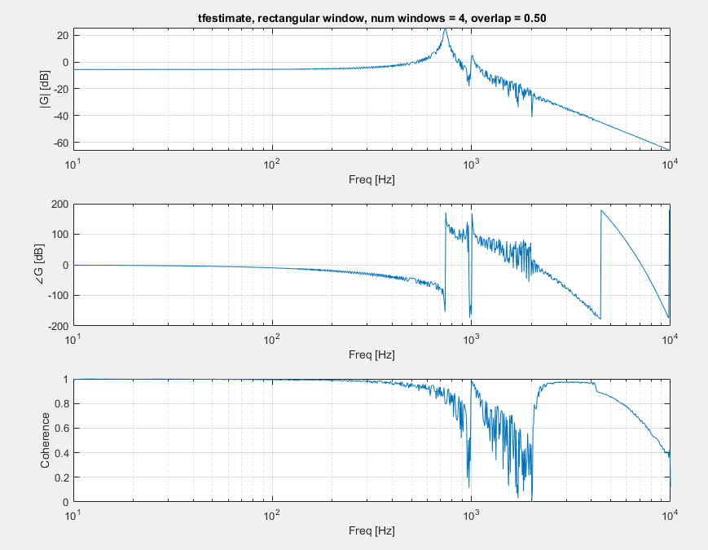

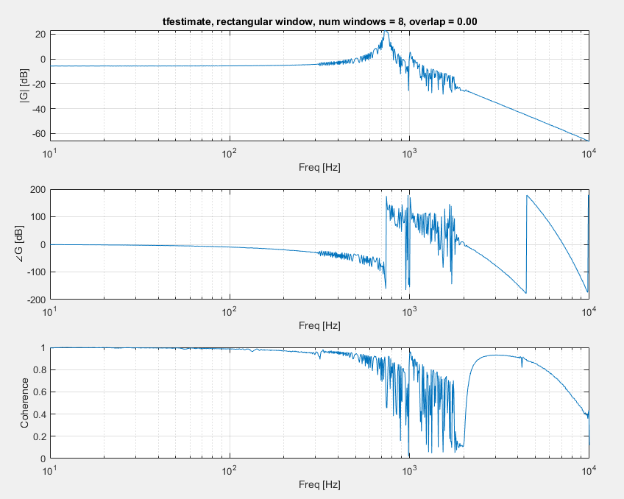

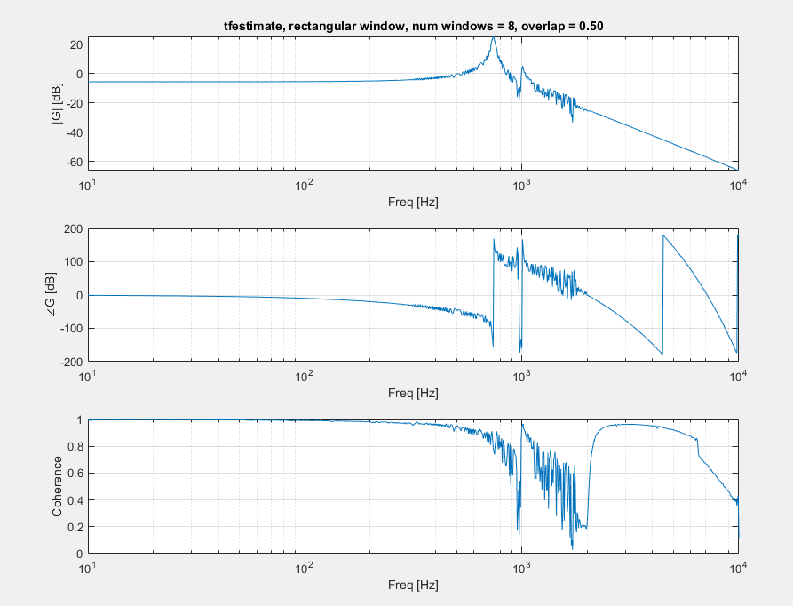

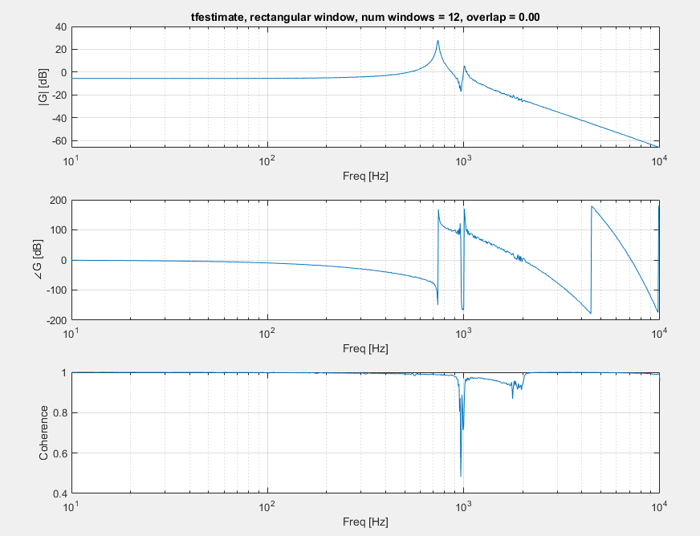

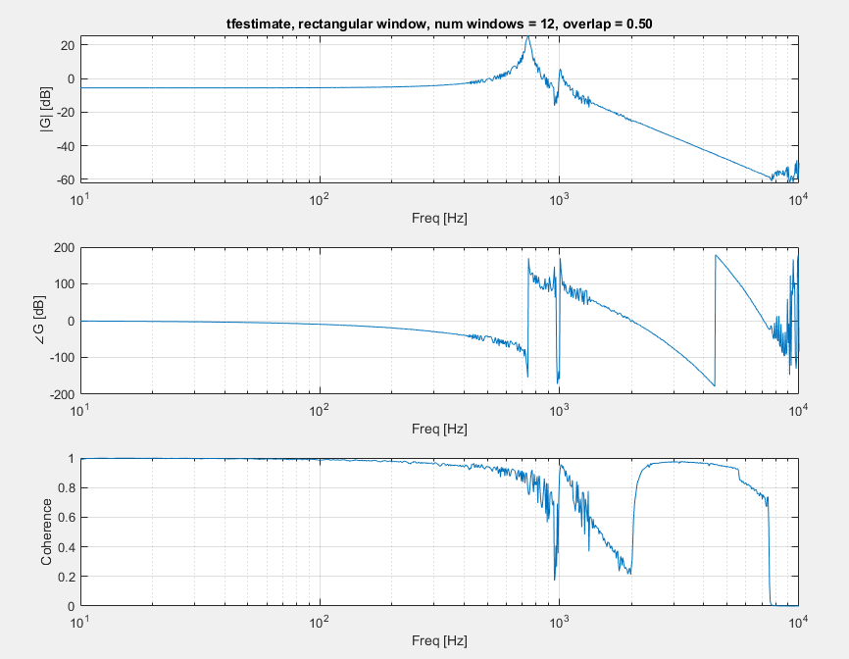

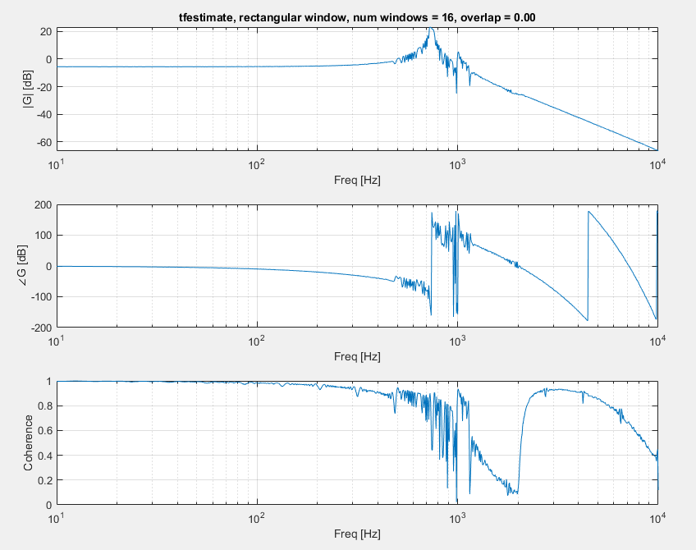

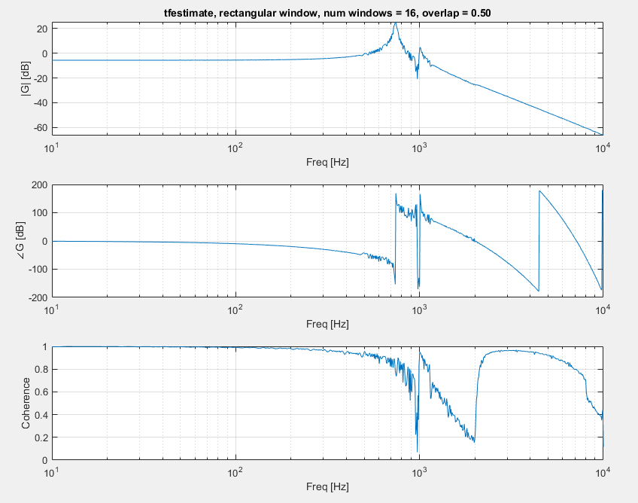

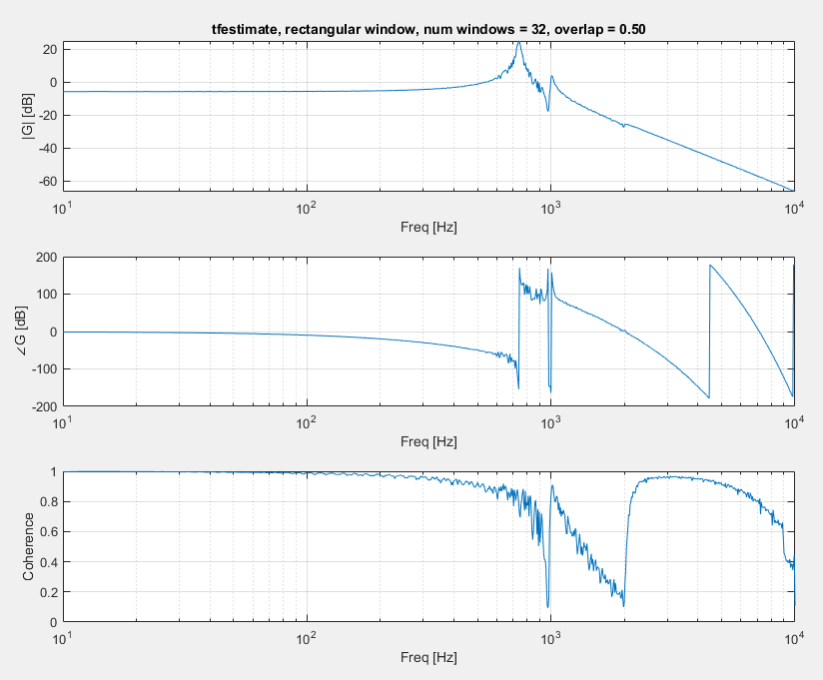

## True windowing at 30e-6

No scaling

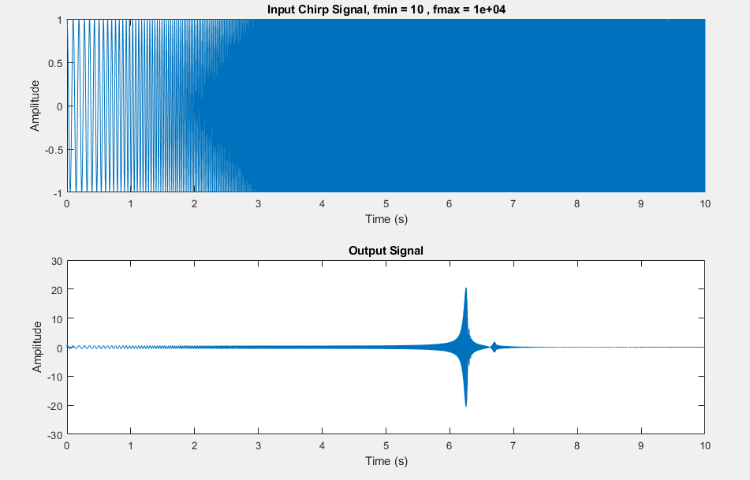

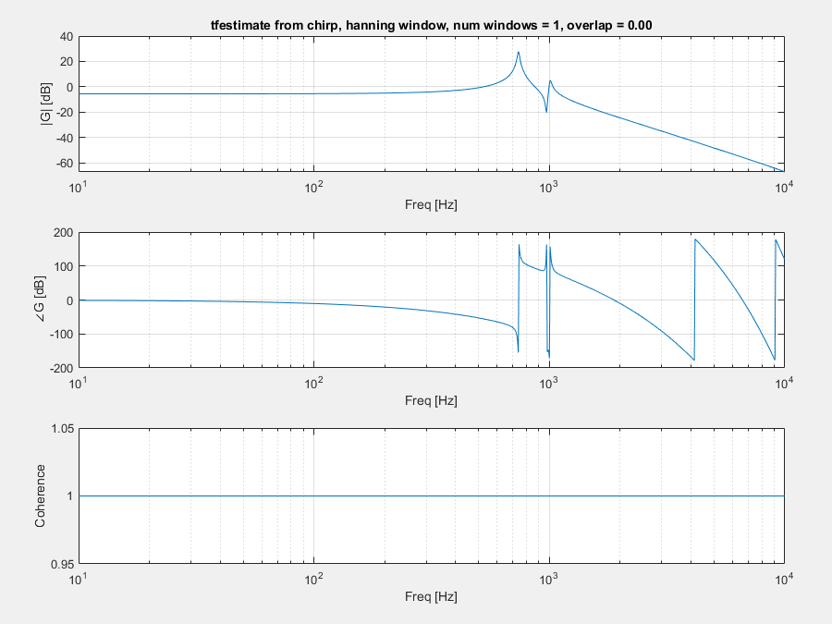

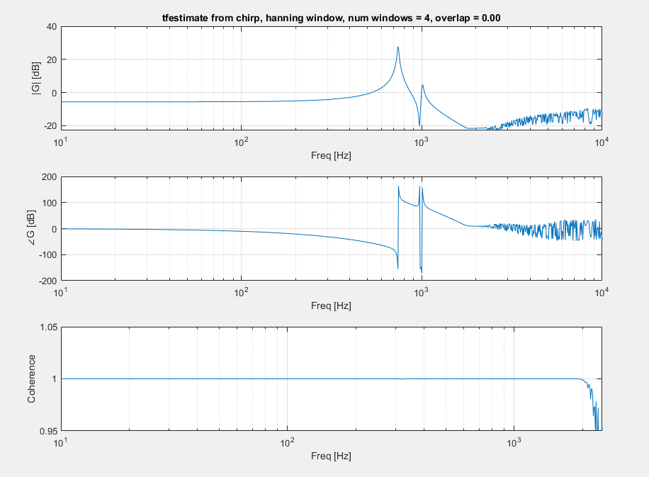

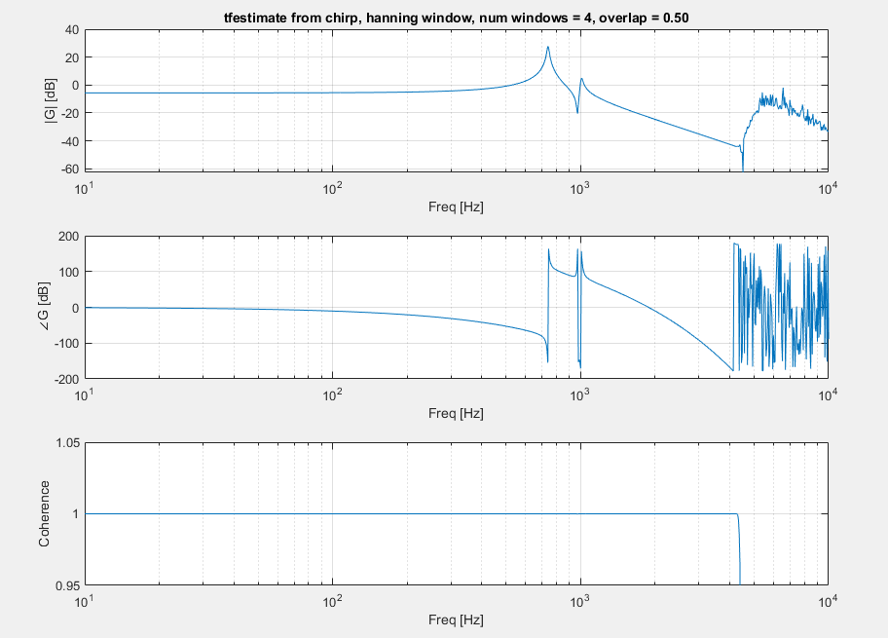

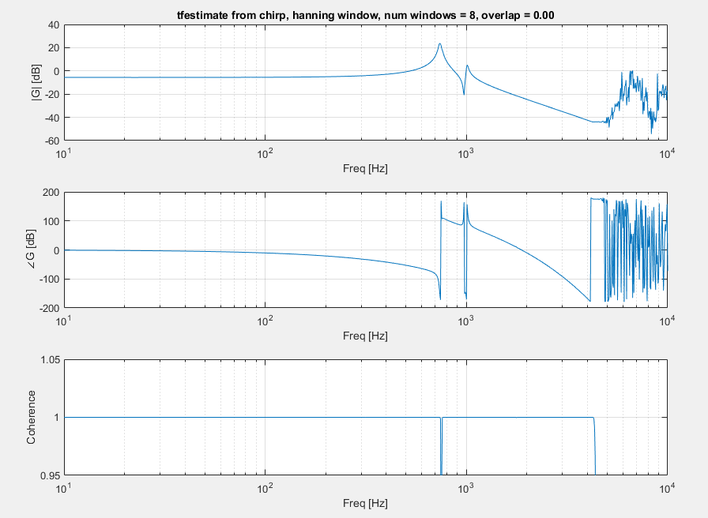

## Windowing with scaling

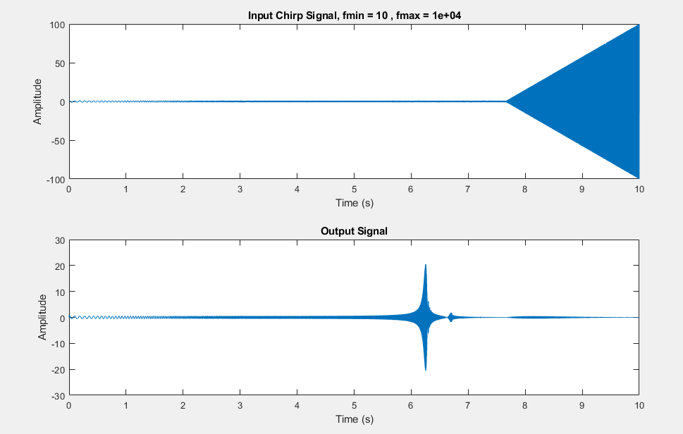

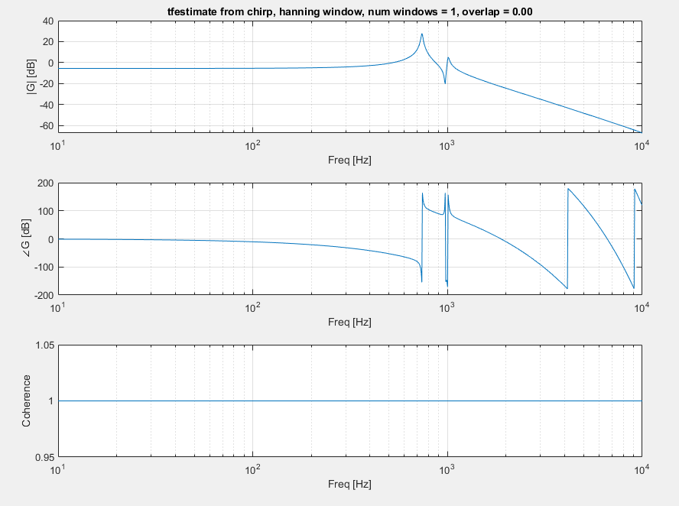

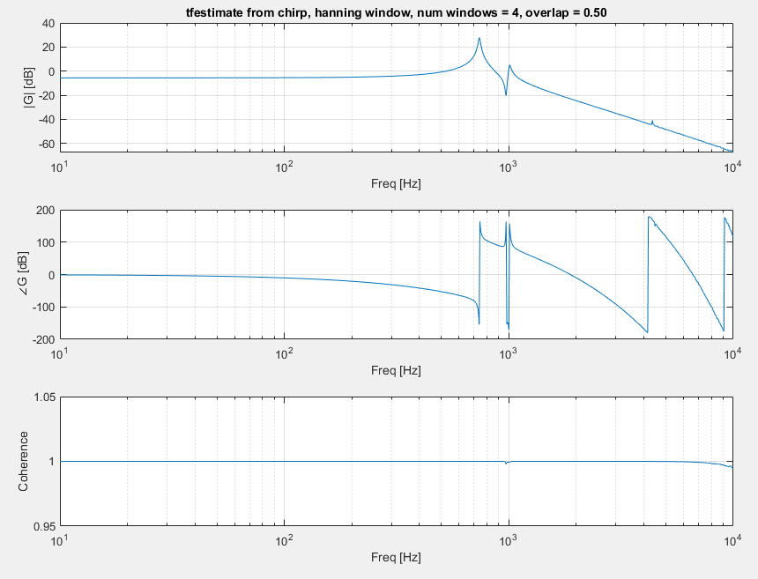

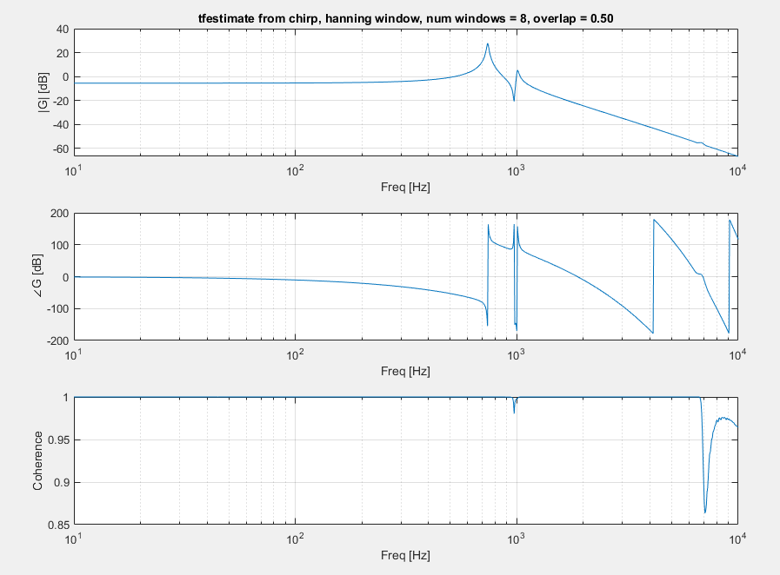

## Multiple Chirps

4 chirps

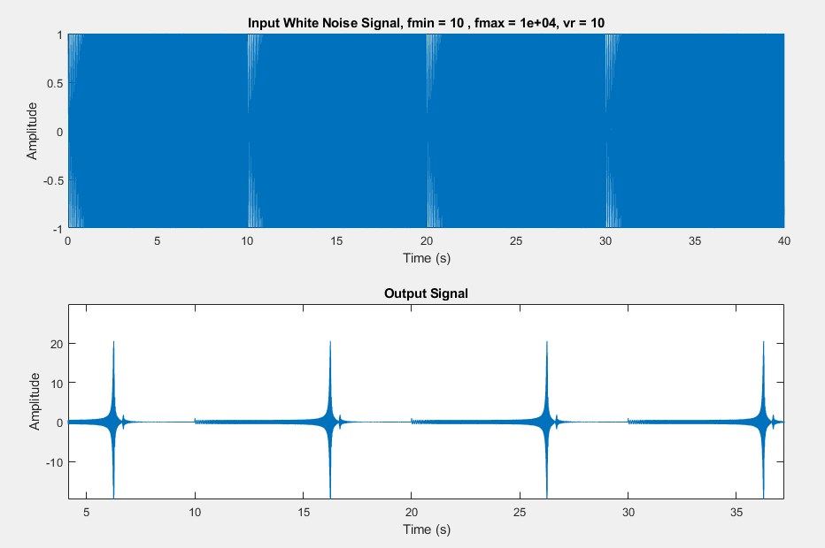

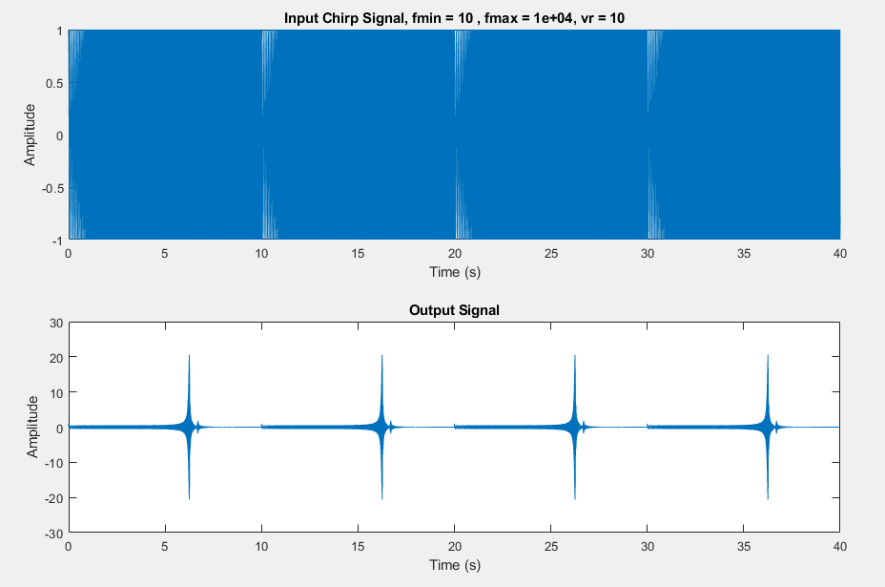

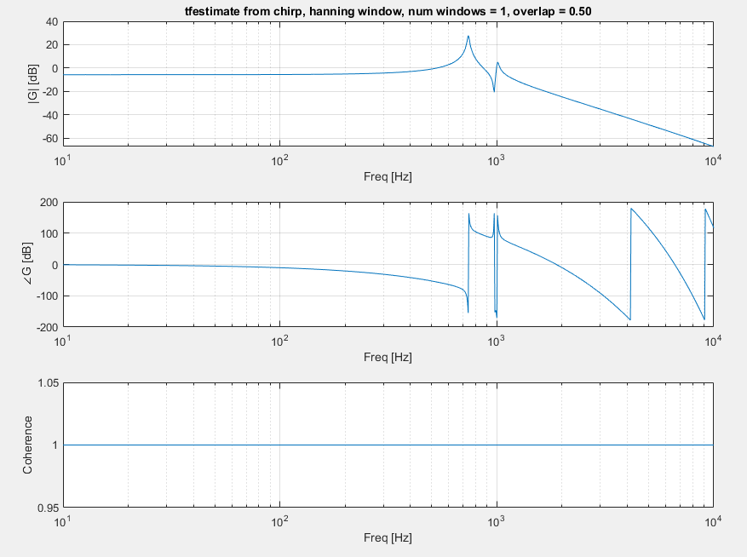

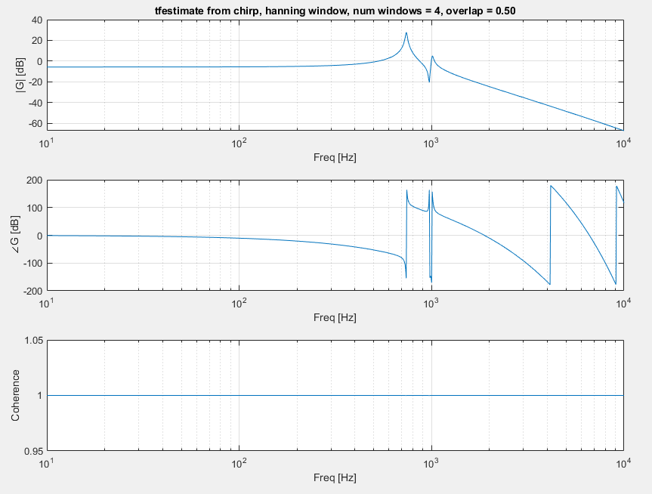

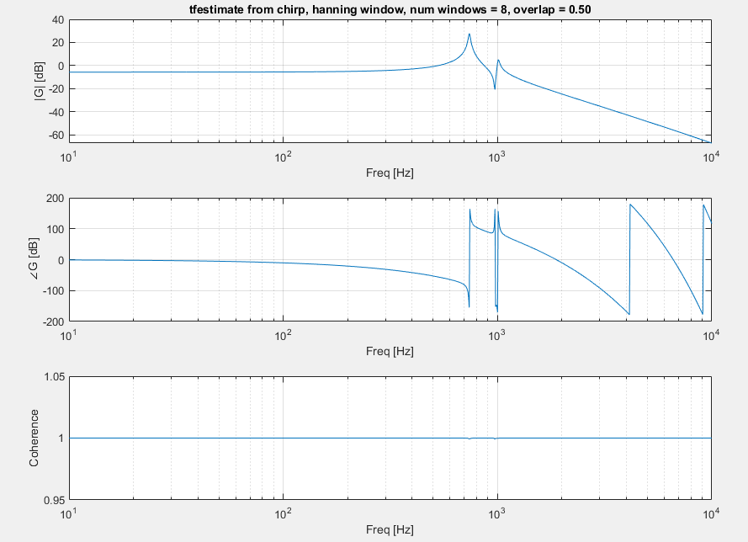

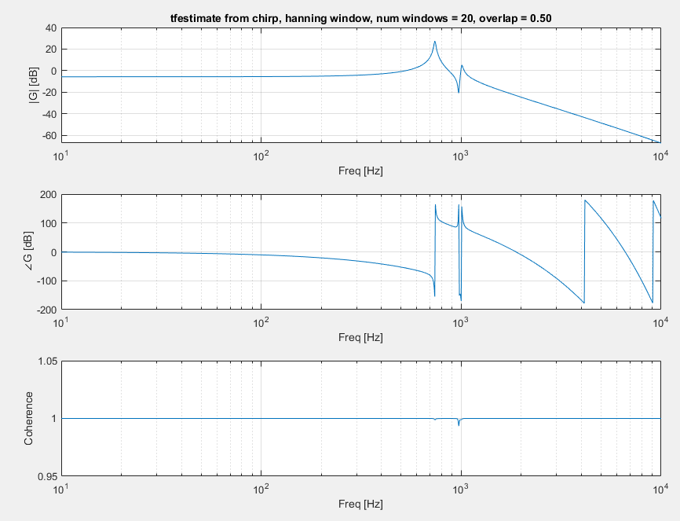

# White Noise

### Fs = 1e5, tmax = 5, vr = 1, tfestimate(1,4)

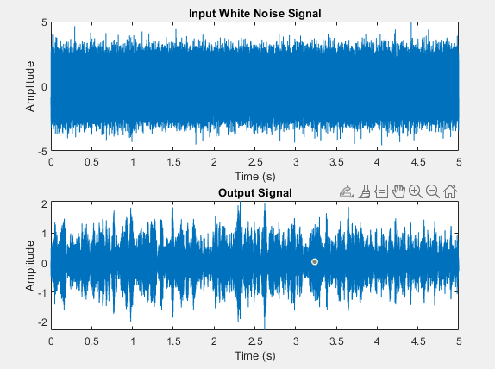

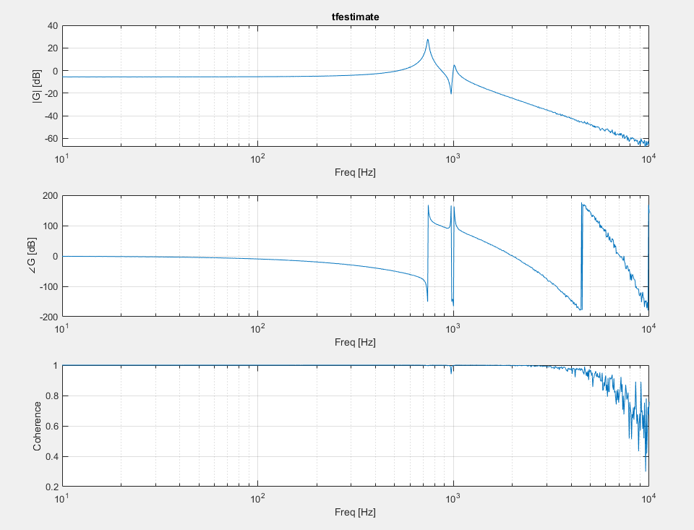

### Fs = 1e5, tmax = 5, vr = 1, tfestimate(-1,4)

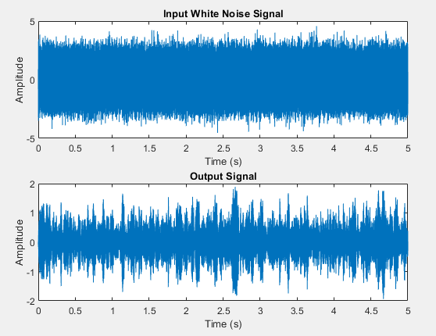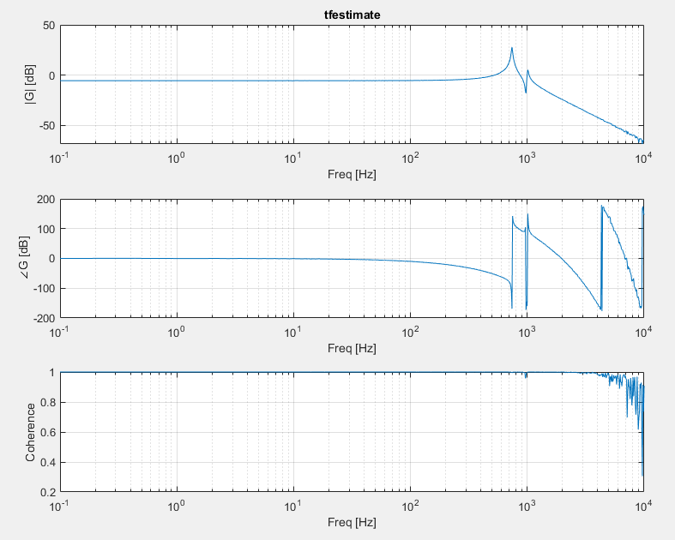

### Fs = 1e5, tmax = 5, vr = 5, tfestimate(-1,4)

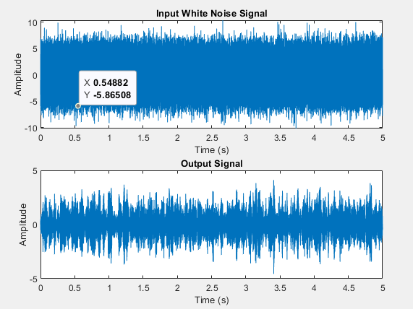

### A graph of a graph AI-generated content may be incorrect. Fs = 1e5, tmax = 5, vr = 10, tfestimate(-1,4)

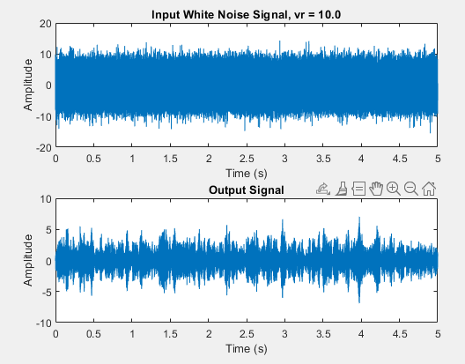

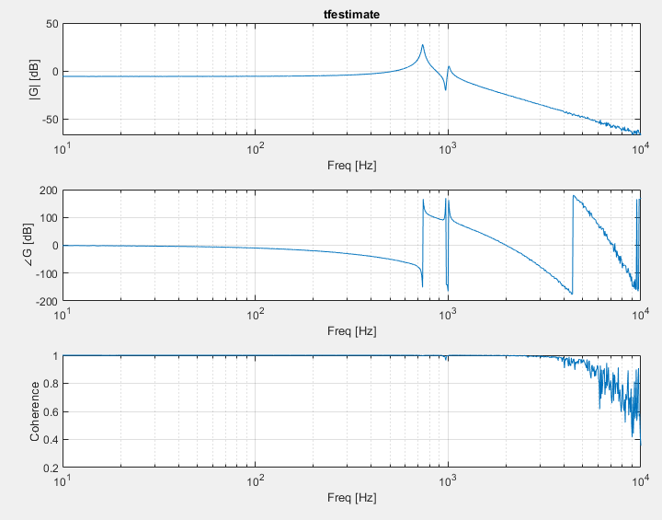

## Windowing

### Fs = 1e5, tmax = 5, vr = 10,

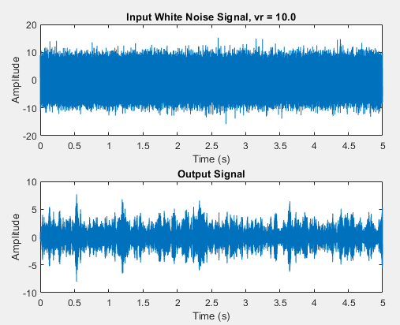

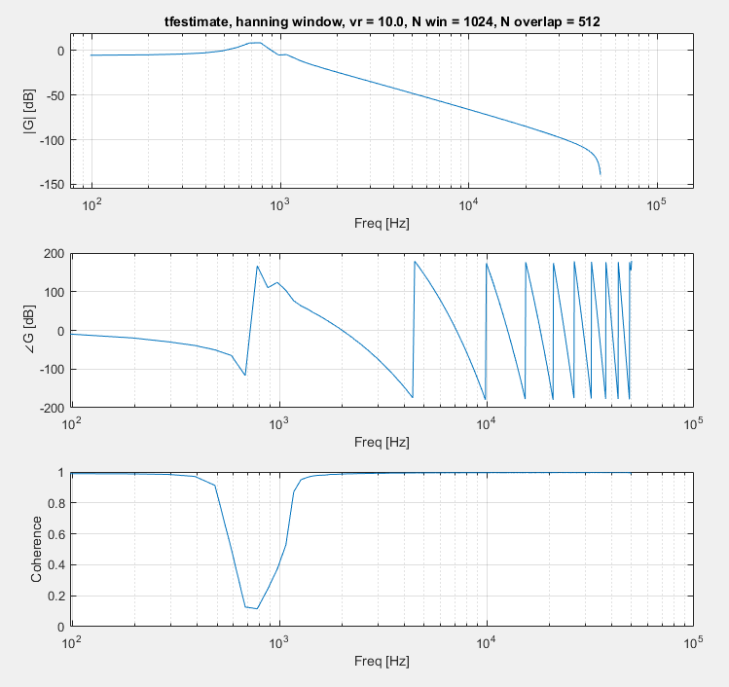

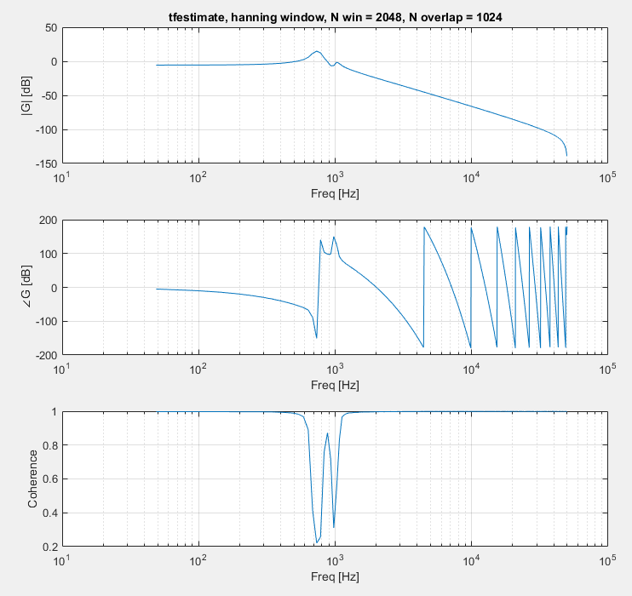

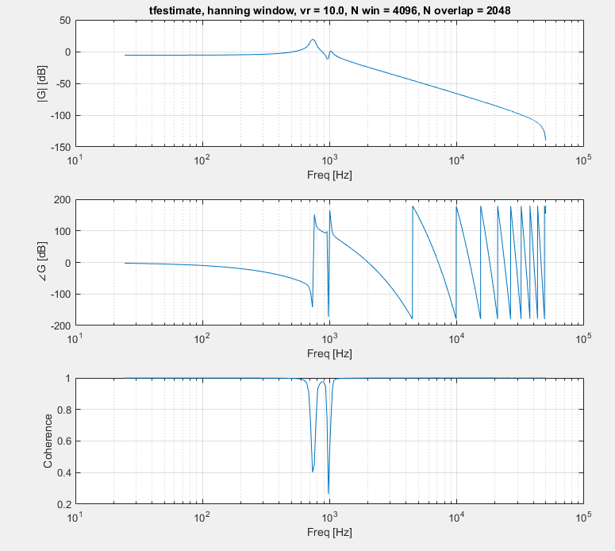

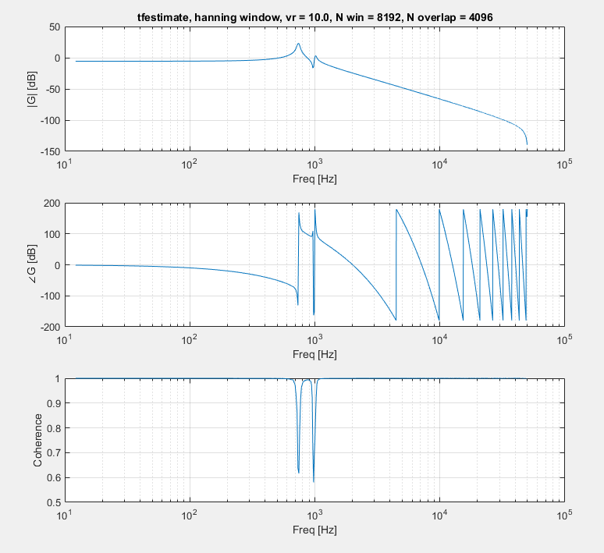

### Proper Hanning

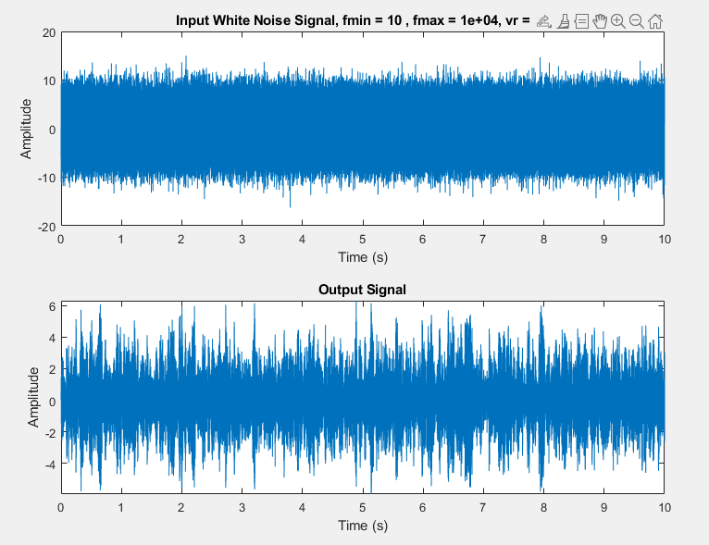

No windowing

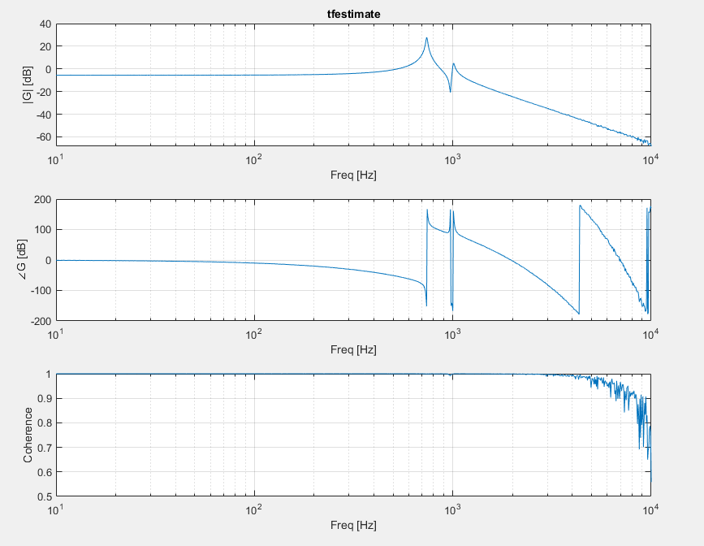

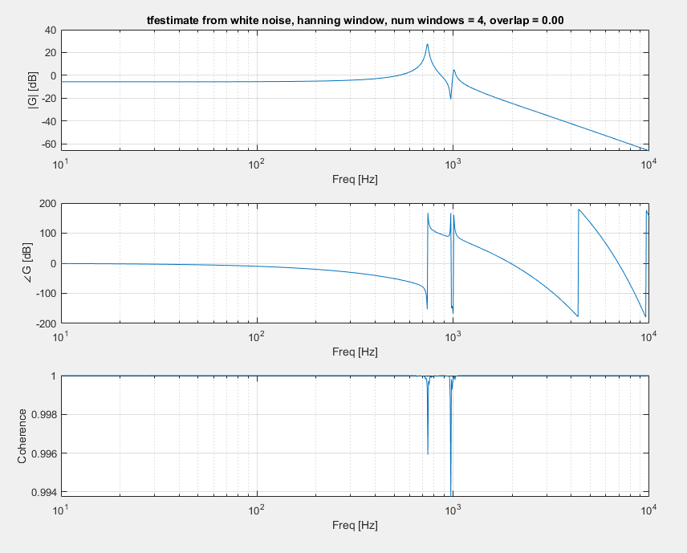

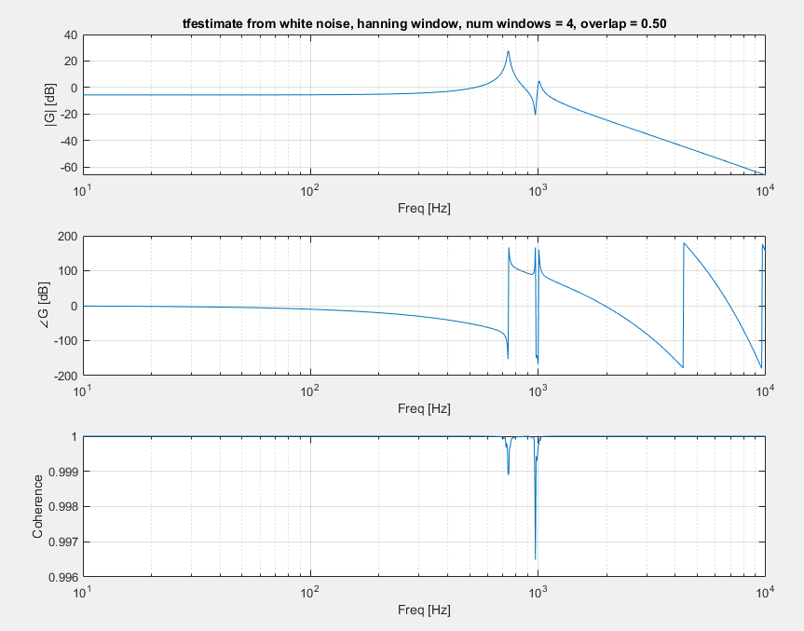

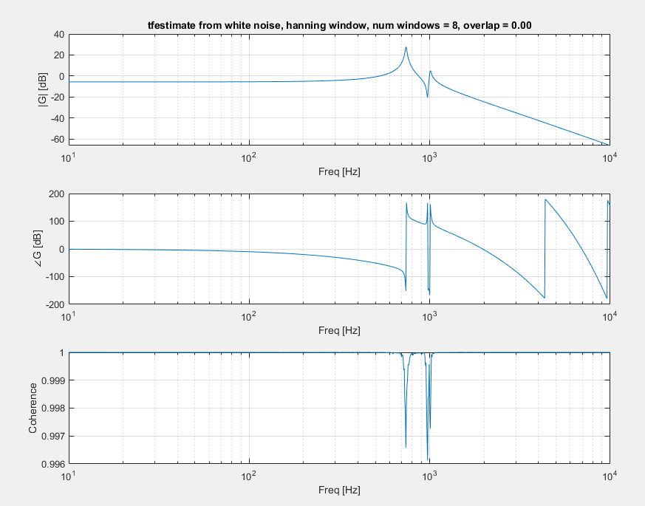

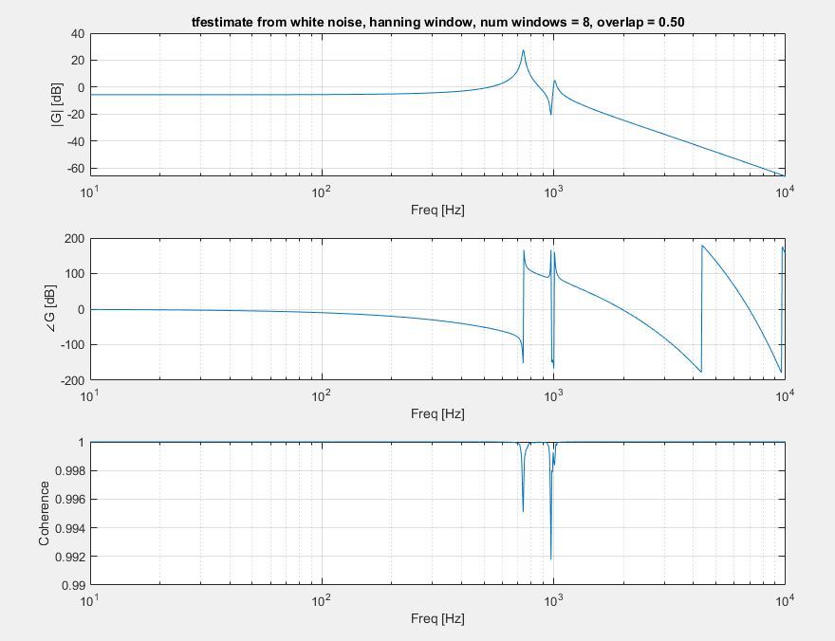

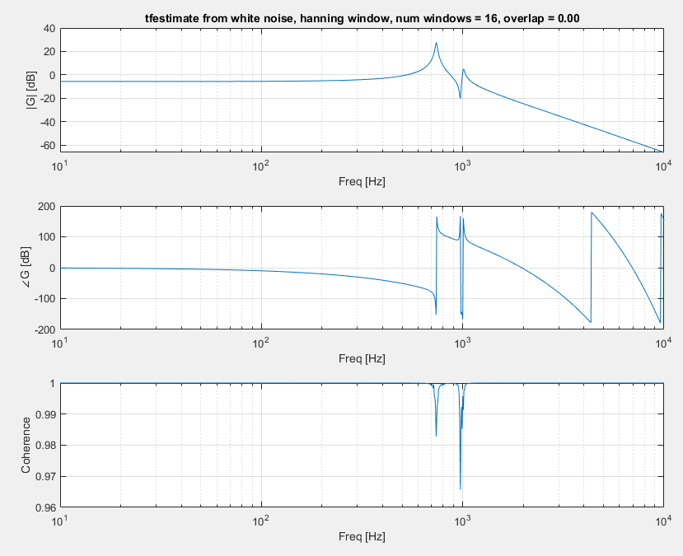

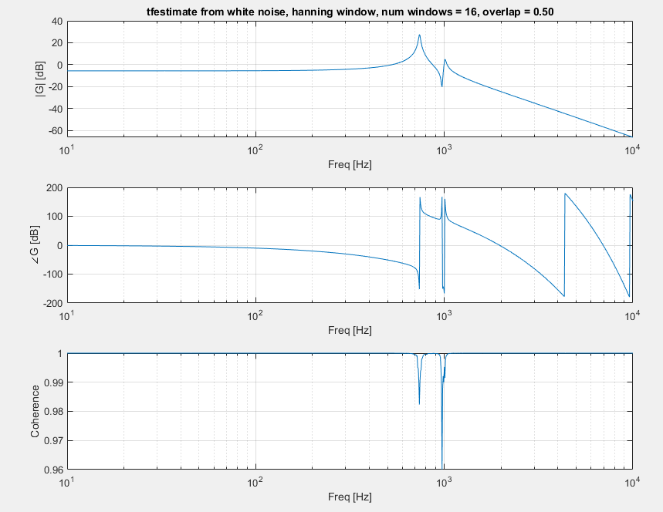

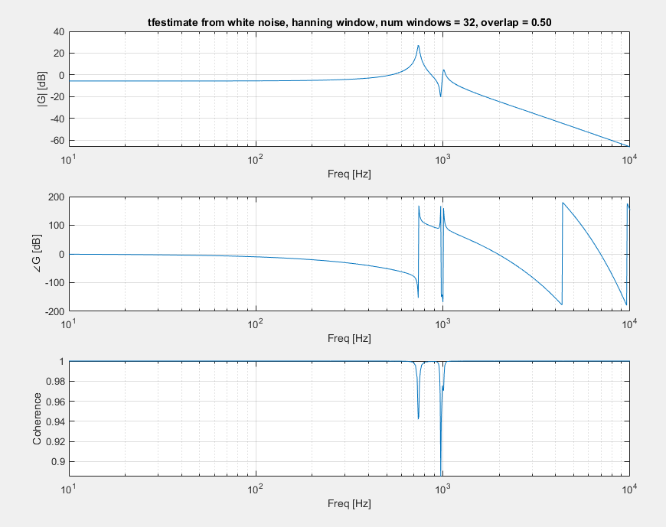

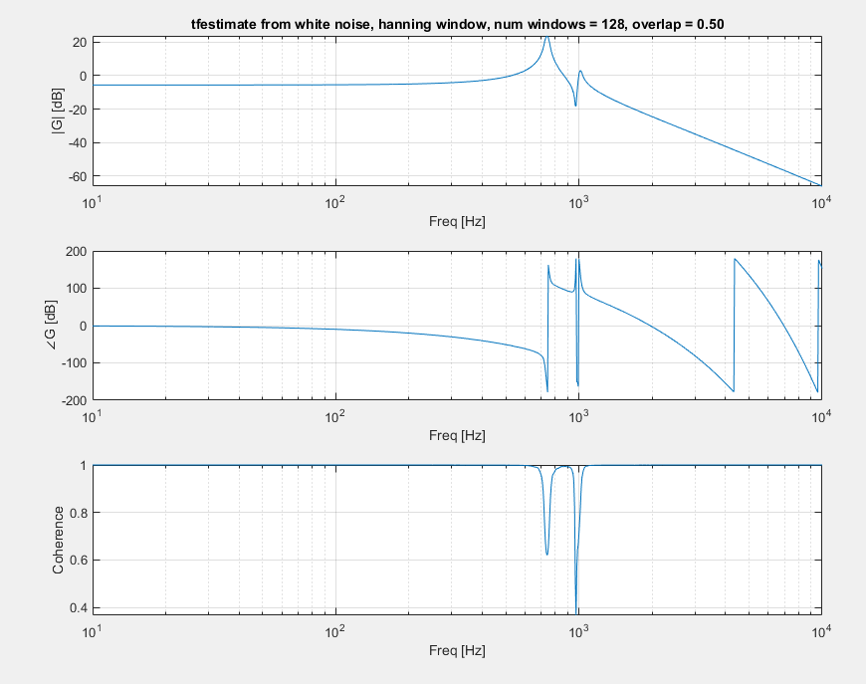

## True Test of Windowing, ts = 30us

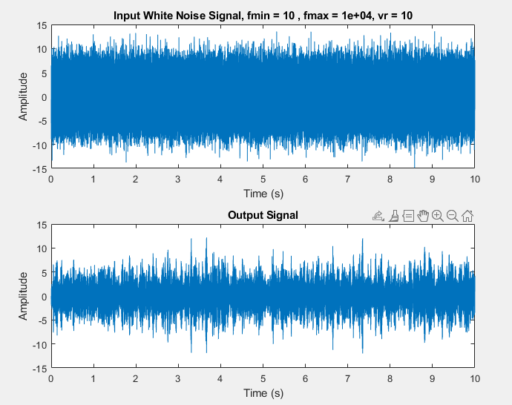

### Jesse’s theory of everything

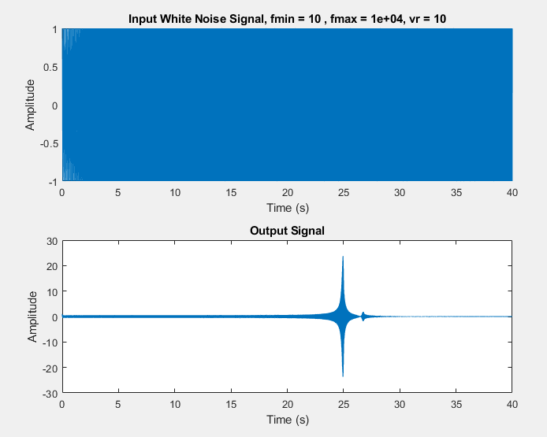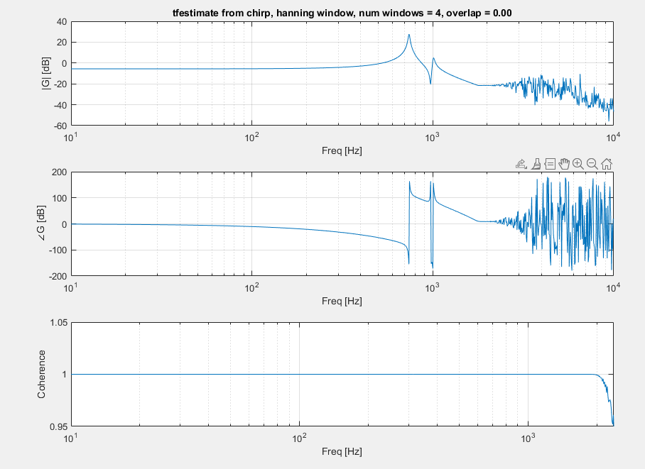

## One last check for higher order modes

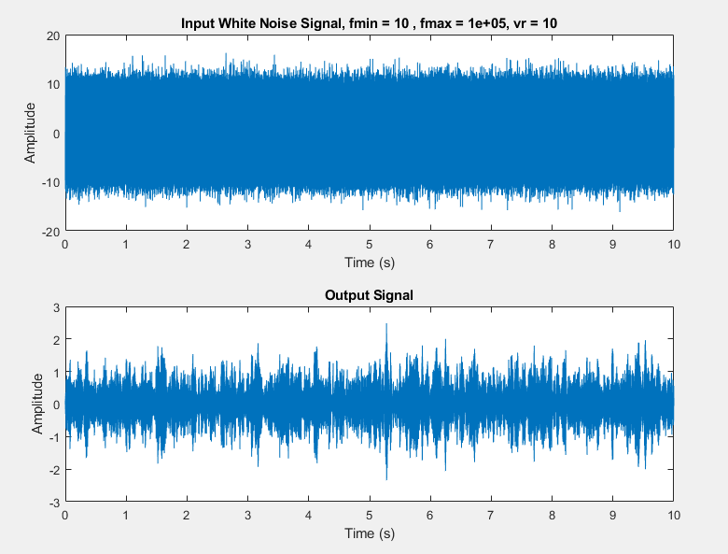

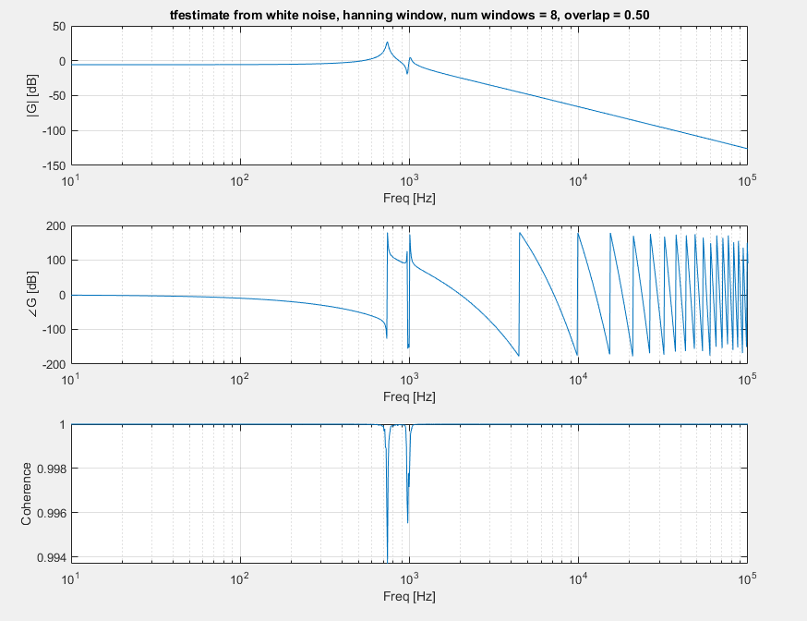

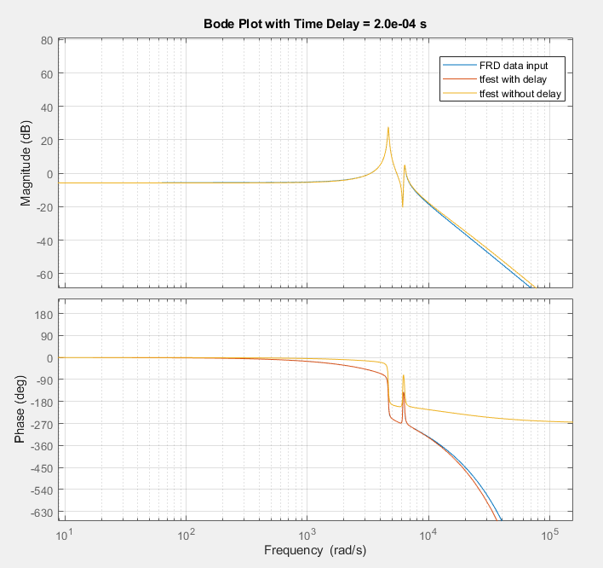

# Tfest

Idk what I’m doing

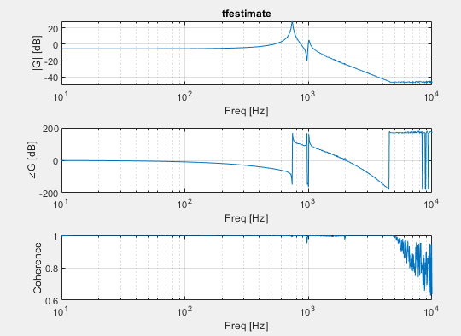

Using 2nd line, 4 poles 2 zeros

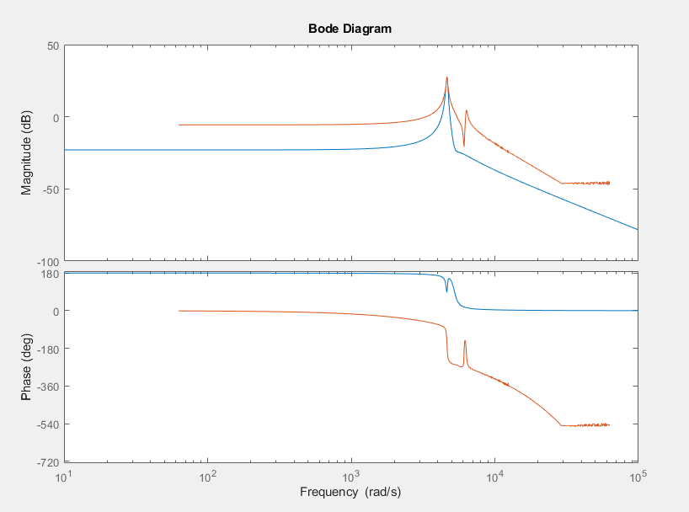

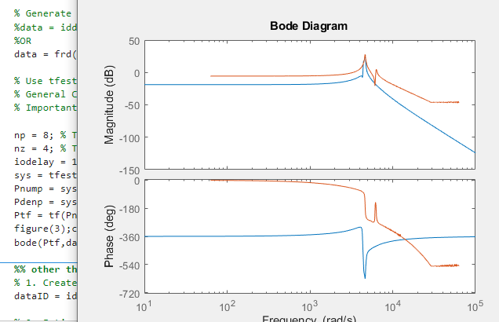

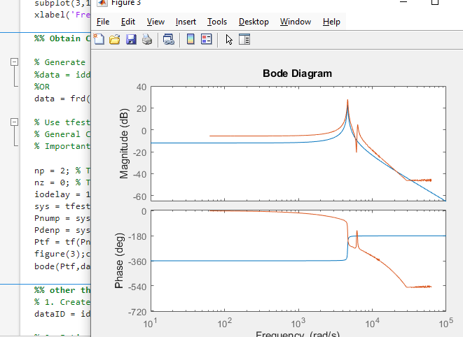

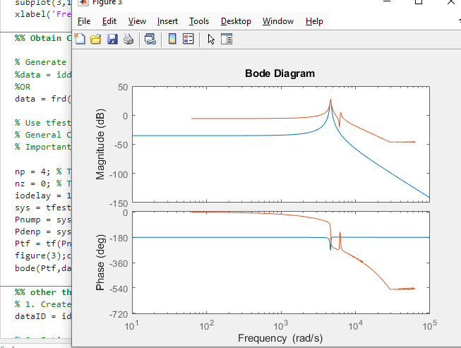

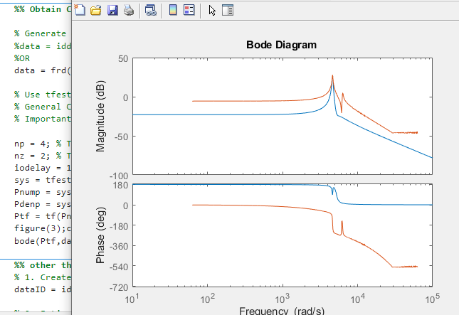

### No scaling

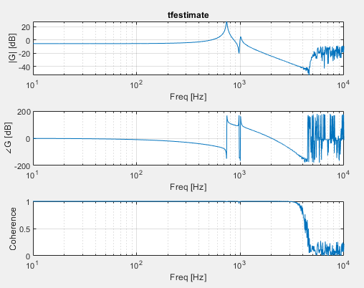

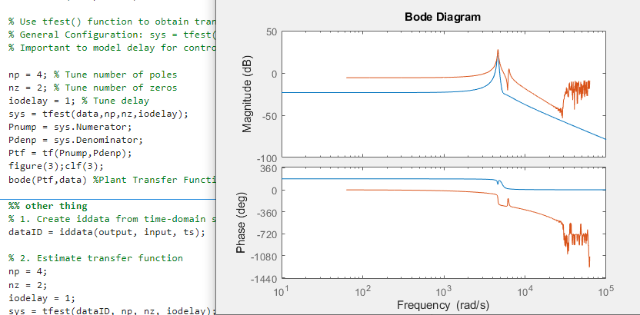

Using first like (iddata)

### Uhhh thanks gpt

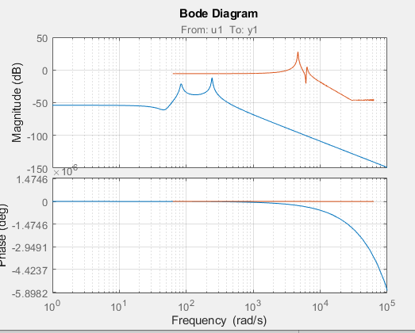

Error in JX_MSD2025_Part1_SystemIdentification (line 136)

bode(Ptf,data) %Plant Transfer Function from Identification

Unrecognized function or variable 'dataFRD'.

Error in JX_MSD2025_Part1_SystemIdentification (line 149)

bode(sys, dataFRD); % overlay fitted model and measured data

## Tuning iodelay

### 1e-3, 5p3z

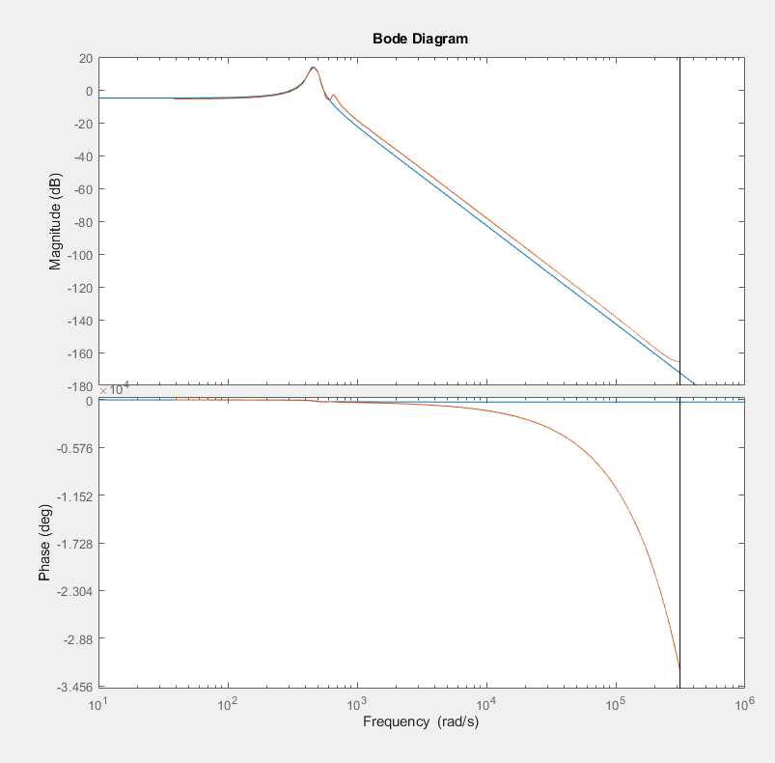

### 1e-4, actually good result with white noise

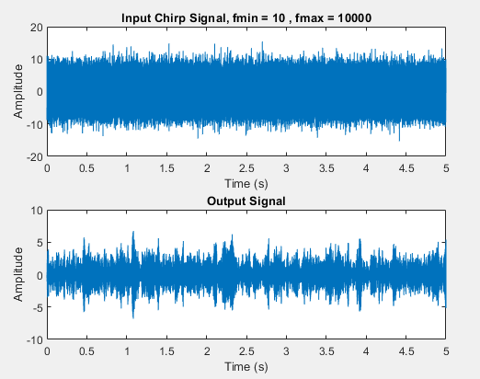

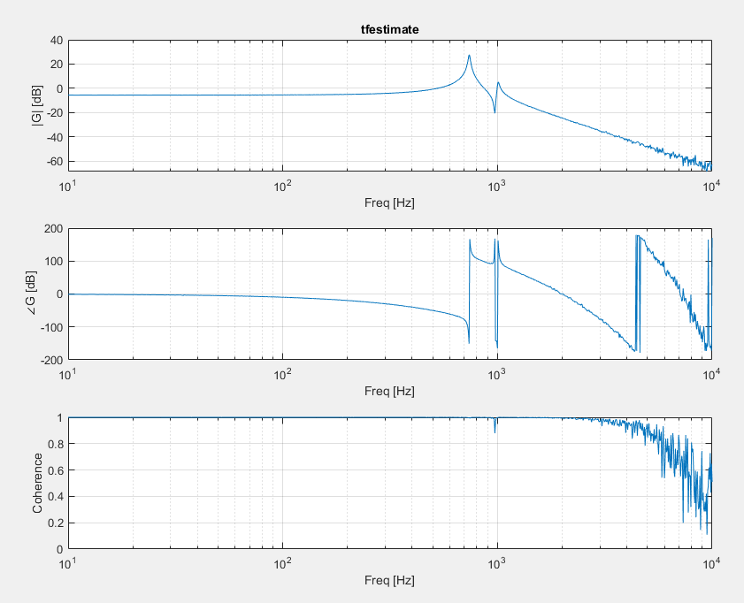

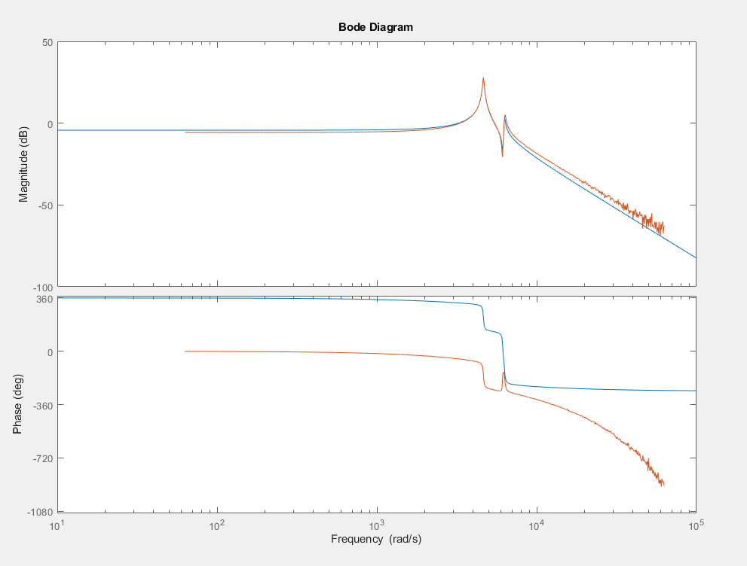

### 10 to 1e4 chirp, 10s, log 1e2 (2e4 to 1e4), no windowing

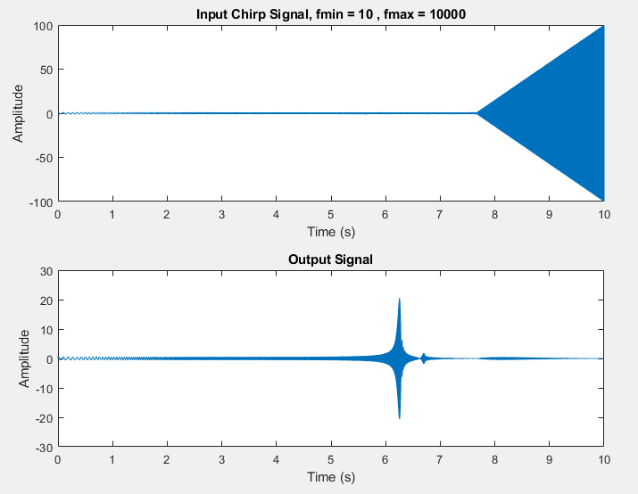

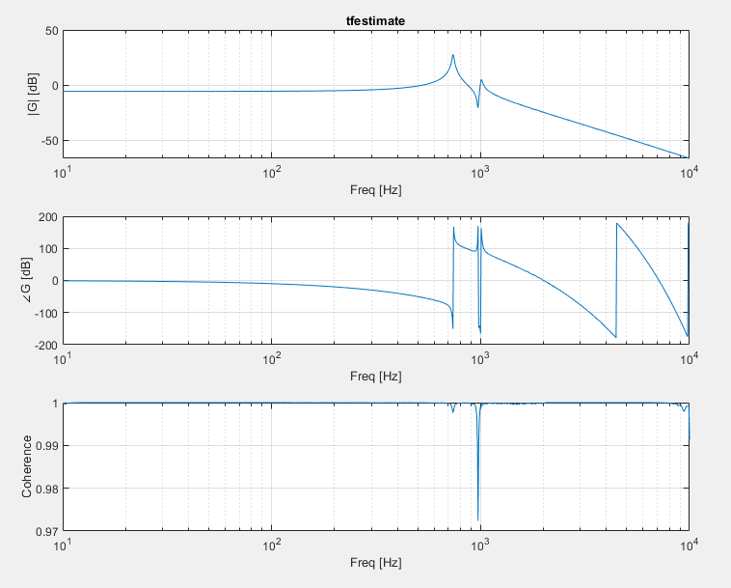

#### Iodelay = 1

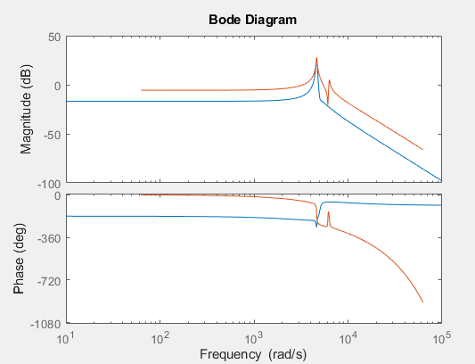

Iodelay = 1e-1

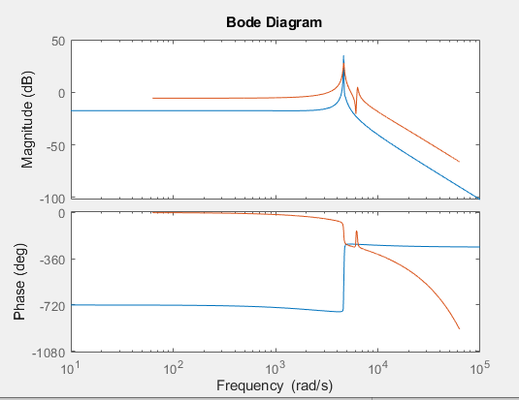

Iodelay = 1e-2

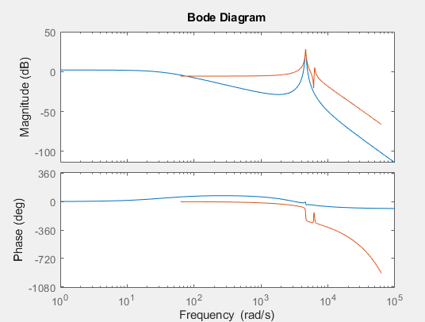

Iodelay = 1e-3

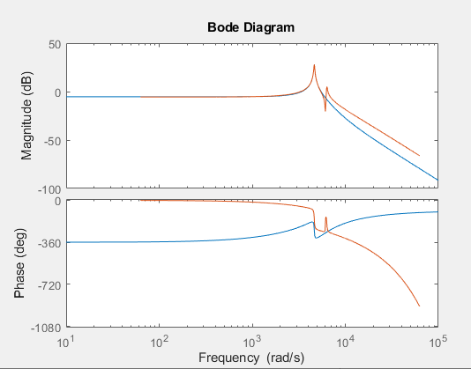

Iodelay = 1e-5

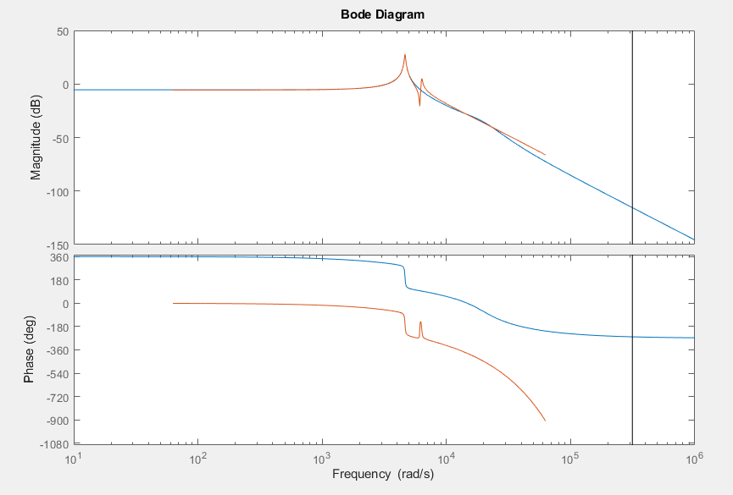

Iodelay = 0

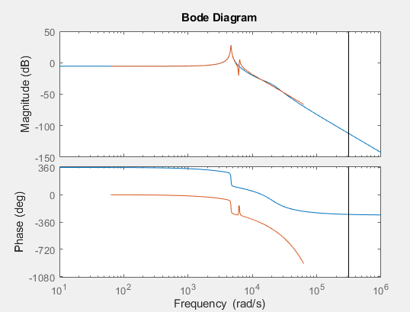

#### Iodelay = 1e-4

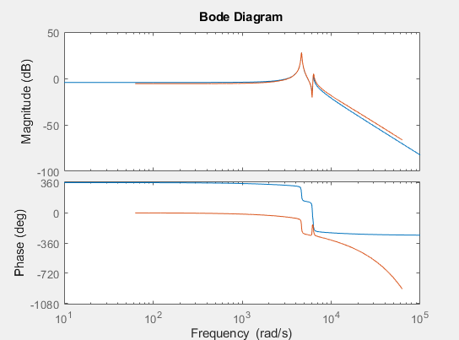

Iodelay = 1.5e-4

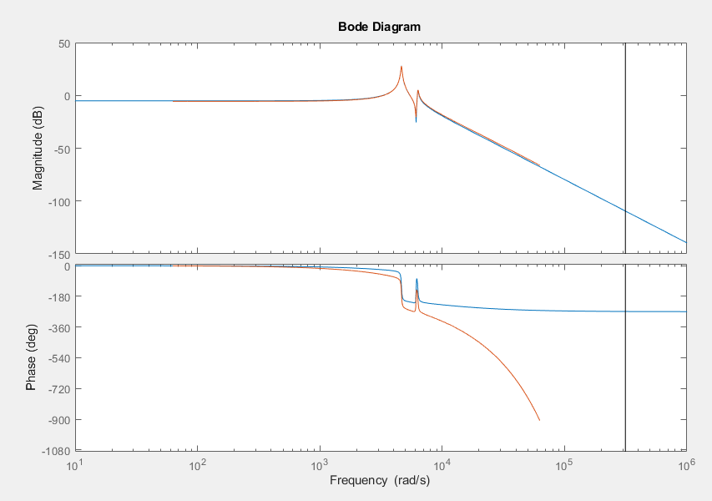

Iodelay = 2e-4

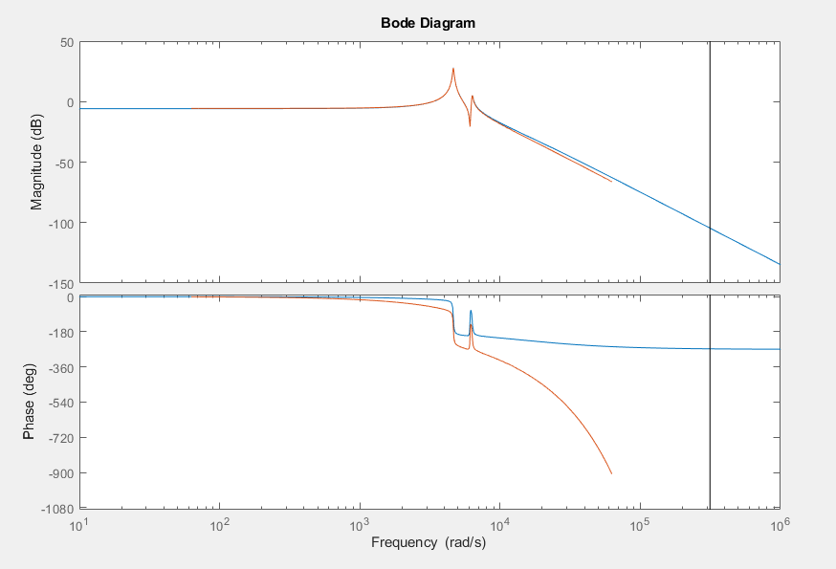

Iodelay = 2.5e-4

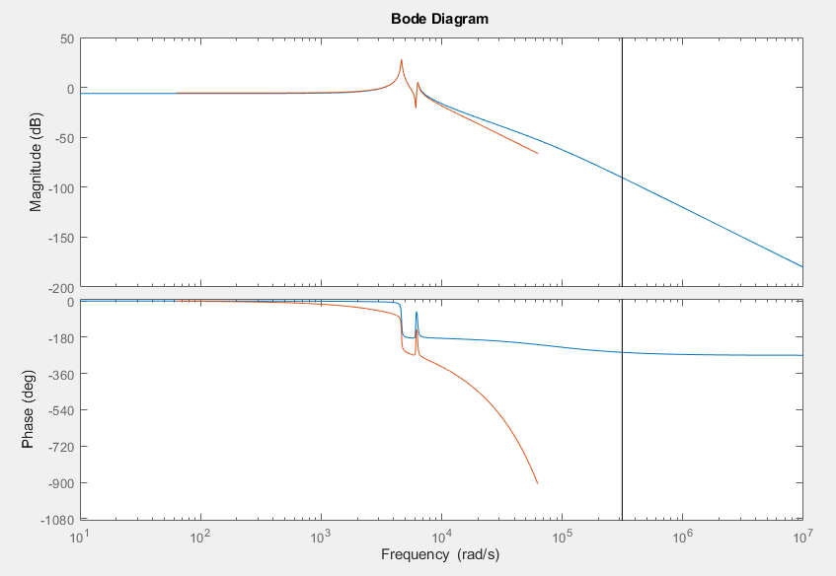

Iodelay = 3e-4

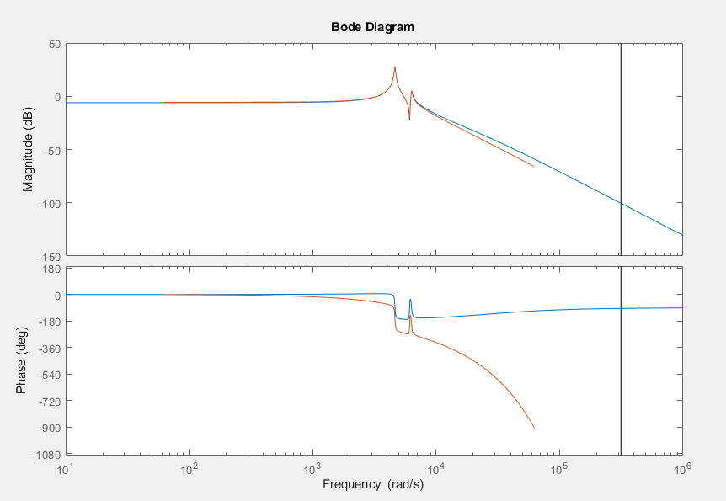

Iodelay = 4e-4

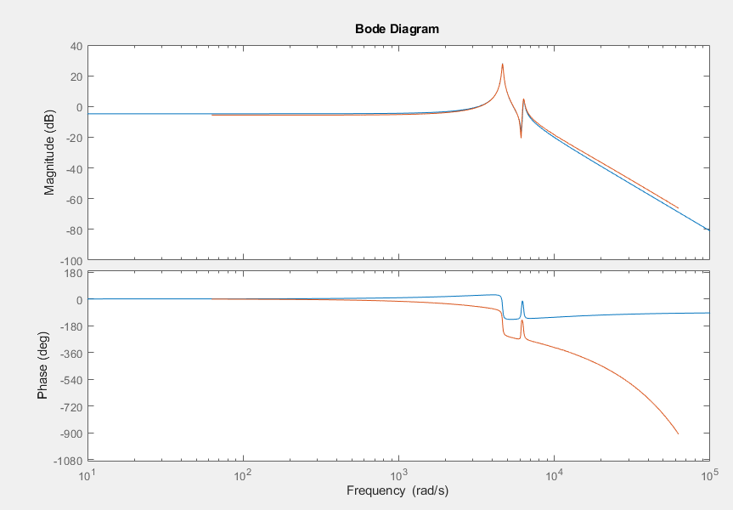

Iodelay = 5e-4

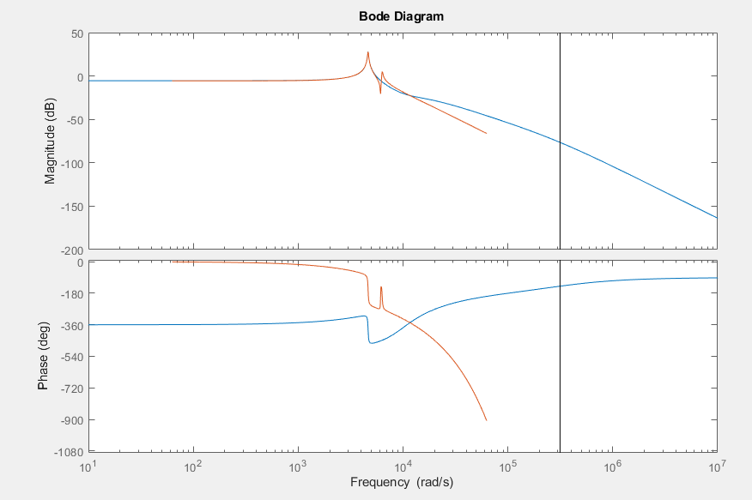

Iodelay 9e-5

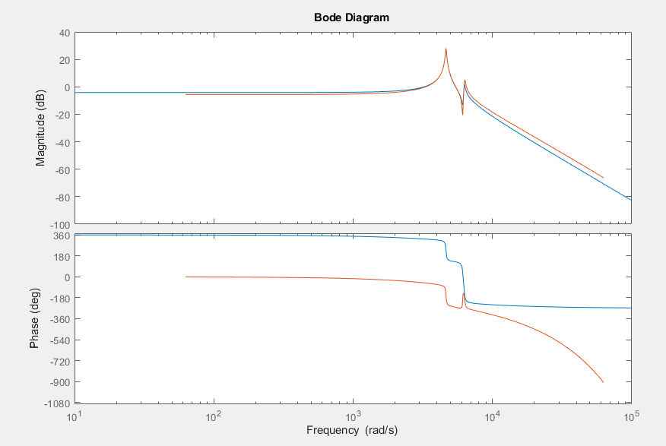

Iodelay 8e-5

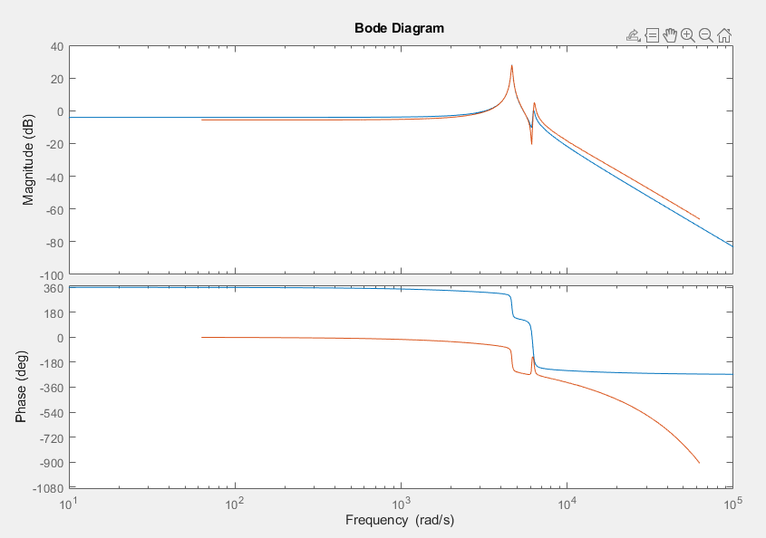

Iodelay 7e-5

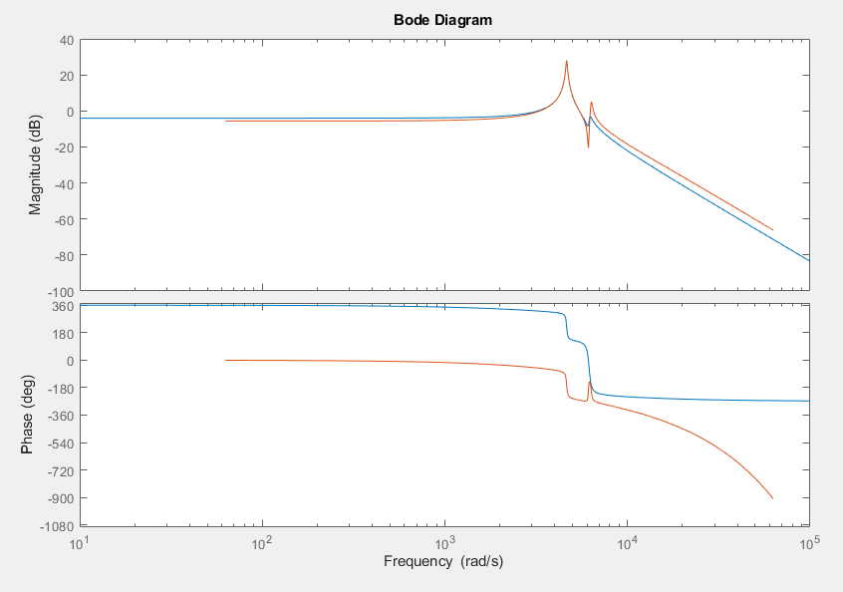

## White noise, tuning poles & zeros

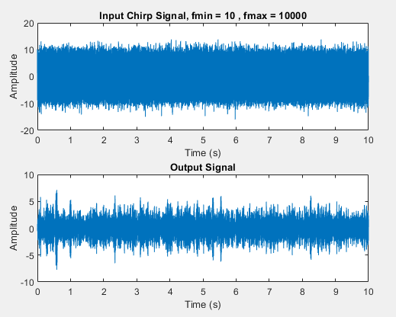

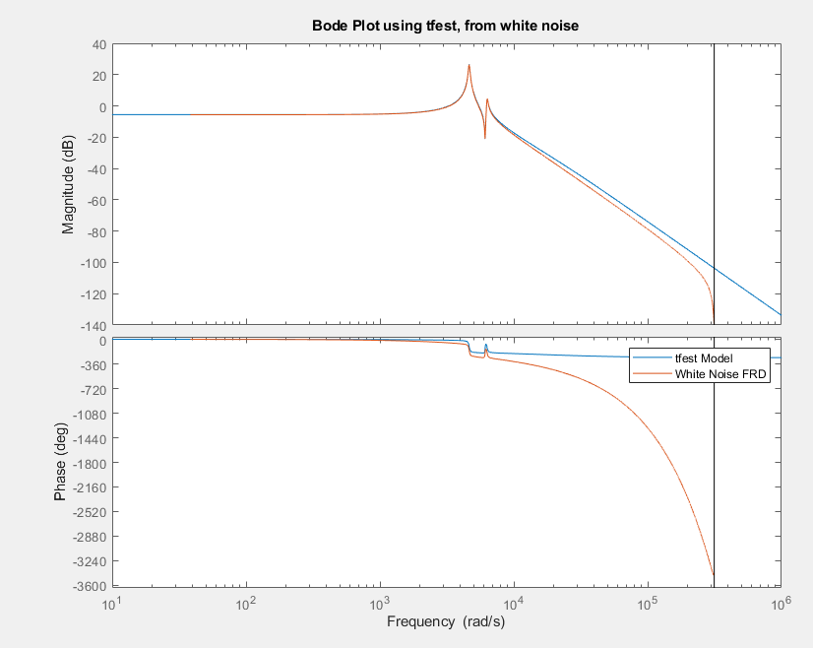

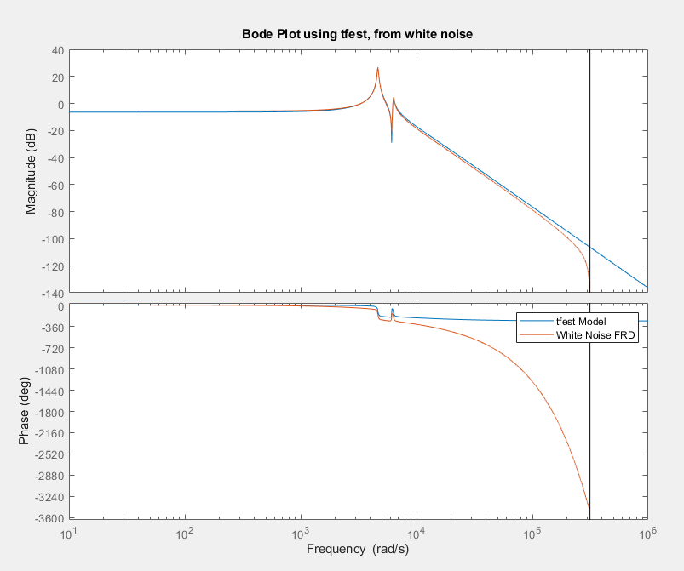

## Chirp, tuning poles & zeros

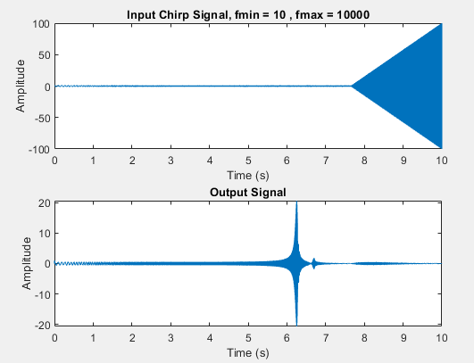

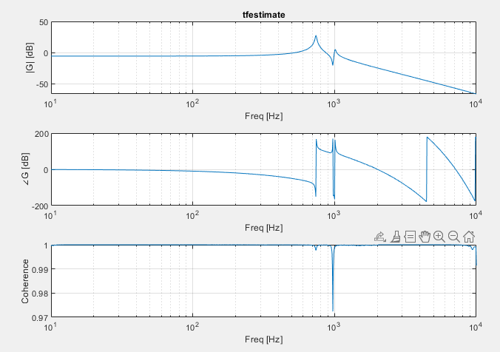

5p 2z

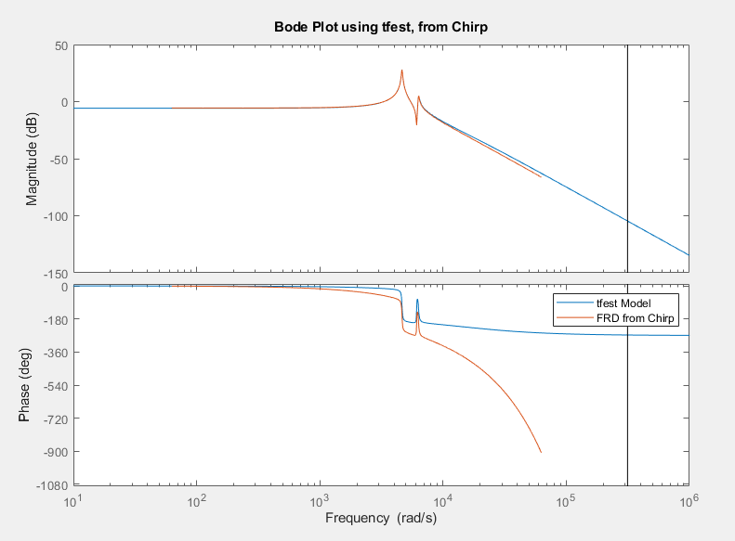

6p3z

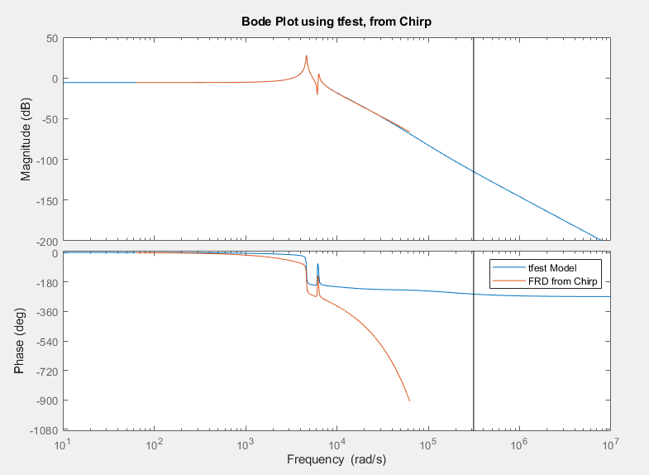

7p4z

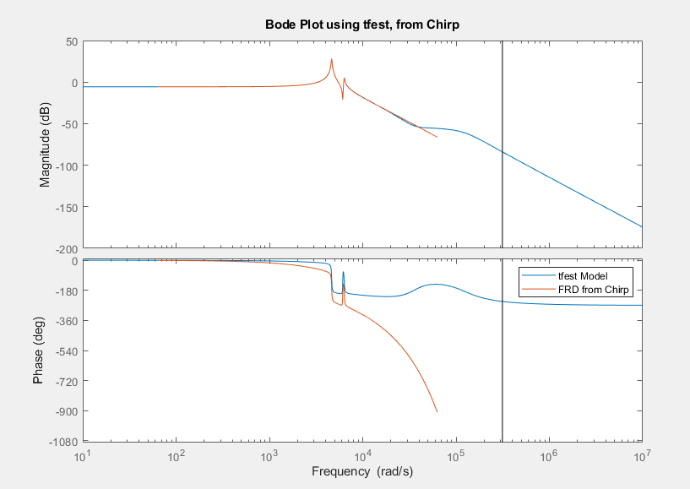

## Final checks with 30e-6

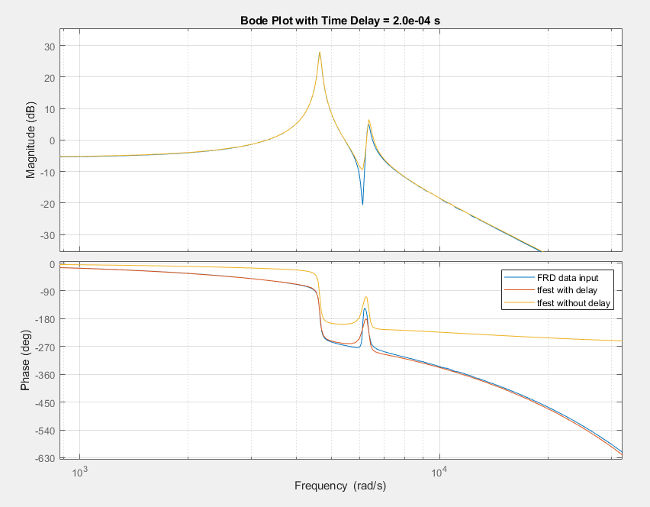

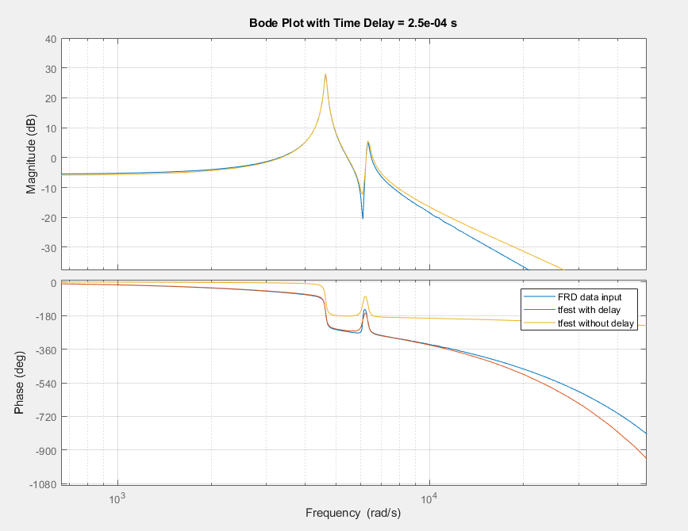

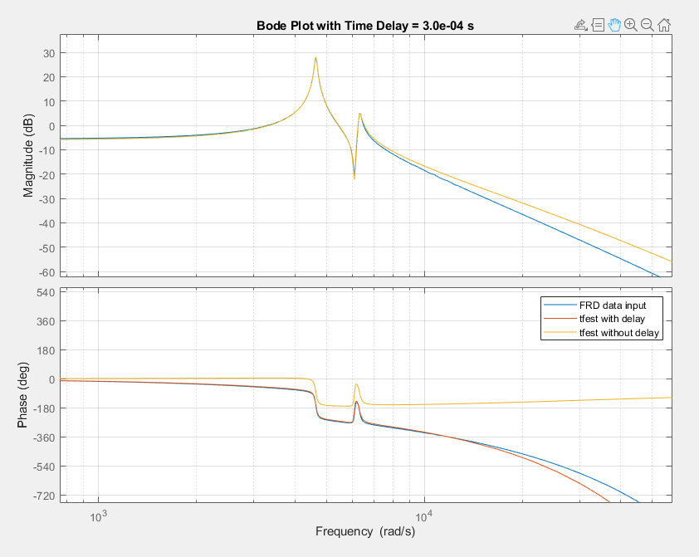

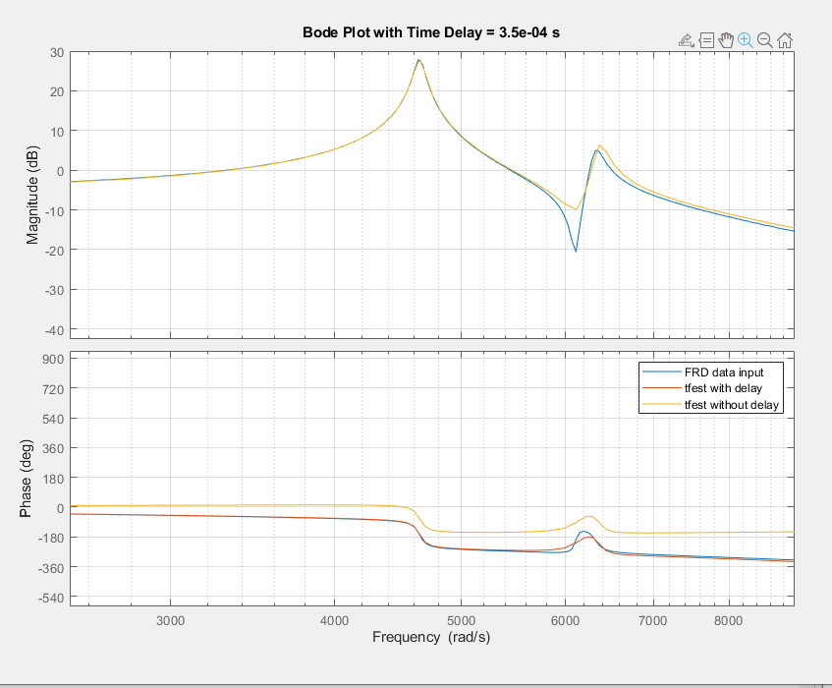

## Last check with 30e-6, scaling

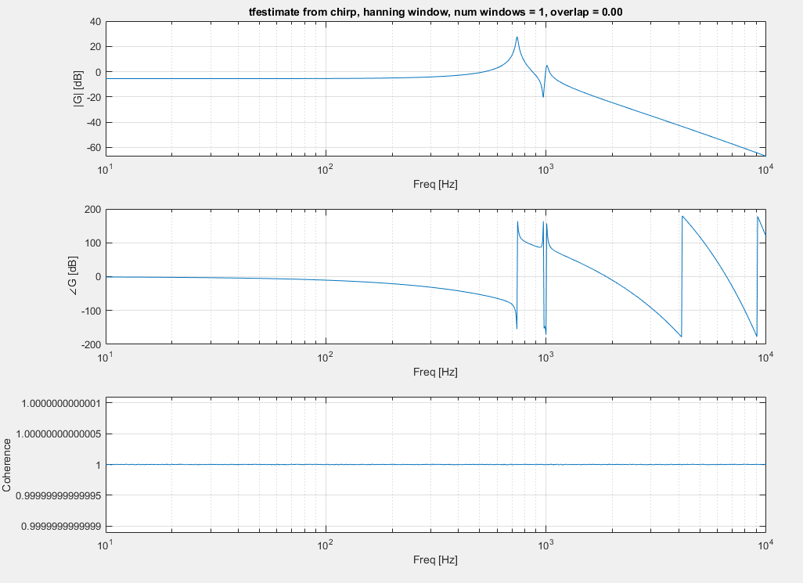

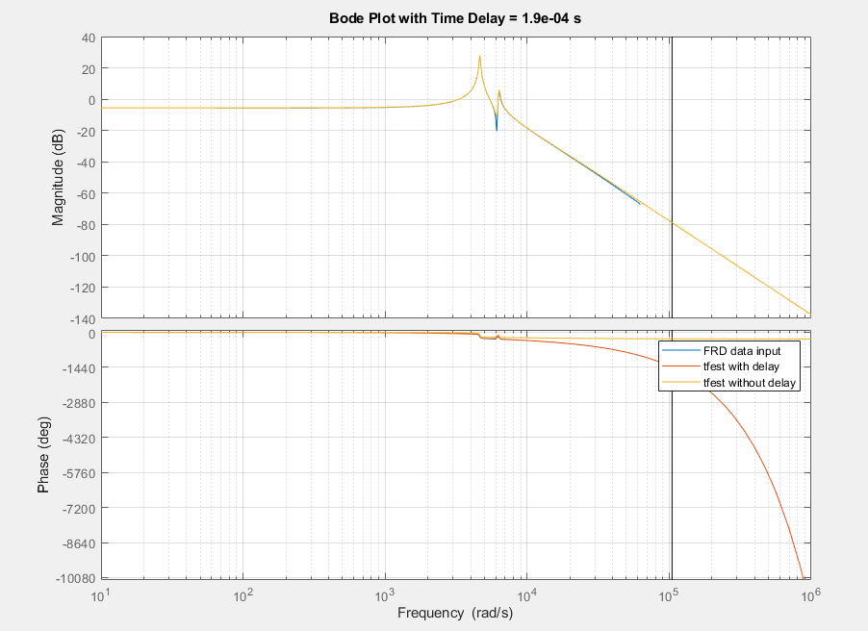

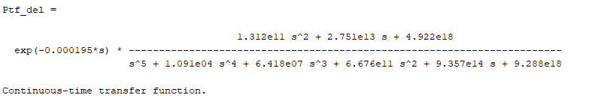

## Now back to higher fs

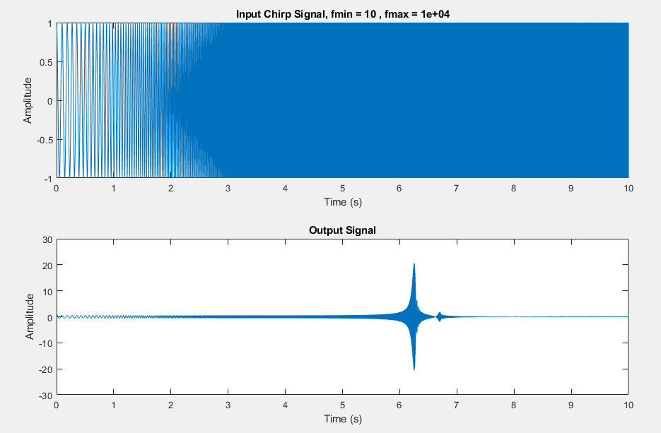

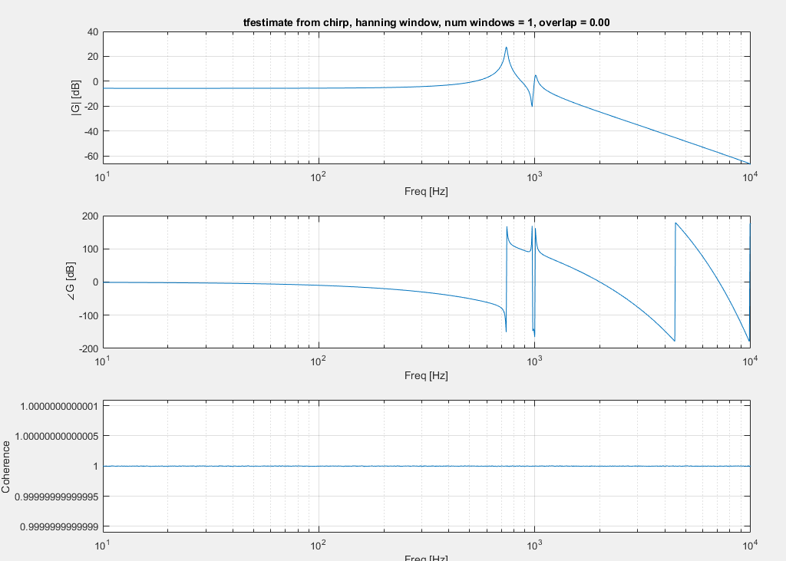

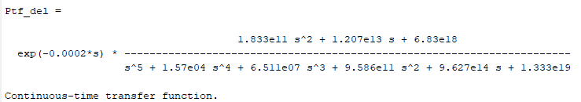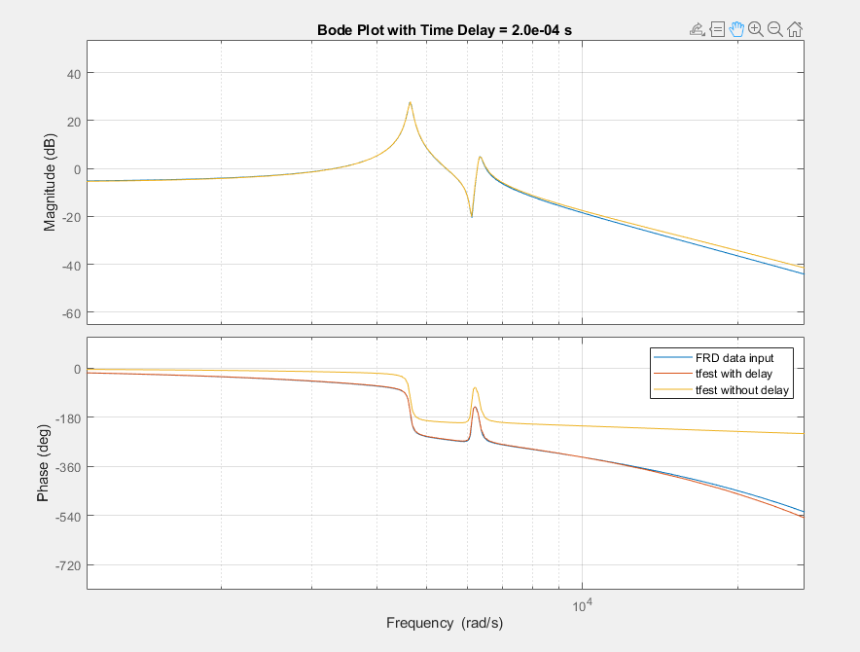

## FINAL TRANSFER FUNCTION

Ptf =

1.833e11 s^2 + 1.207e13 s + 6.83e18

-----------------------------------------------------------------------

s^5 + 1.57e04 s^4 + 6.511e07 s^3 + 9.586e11 s^2 + 9.627e14 s + 1.333e19

Continuous-time transfer function.

Model Properties

Ptf_corr =

1.375e-08 s^2 + 9.056e-07 s + 0.5124

-------------------------------------------------------------------------------

7.502e-20 s^5 + 1.178e-15 s^4 + 4.885e-12 s^3 + 7.191e-08 s^2 + 7.222e-05 s + 1

## Adding Time Delay

### 10 to 3e3, chirp, w time delay

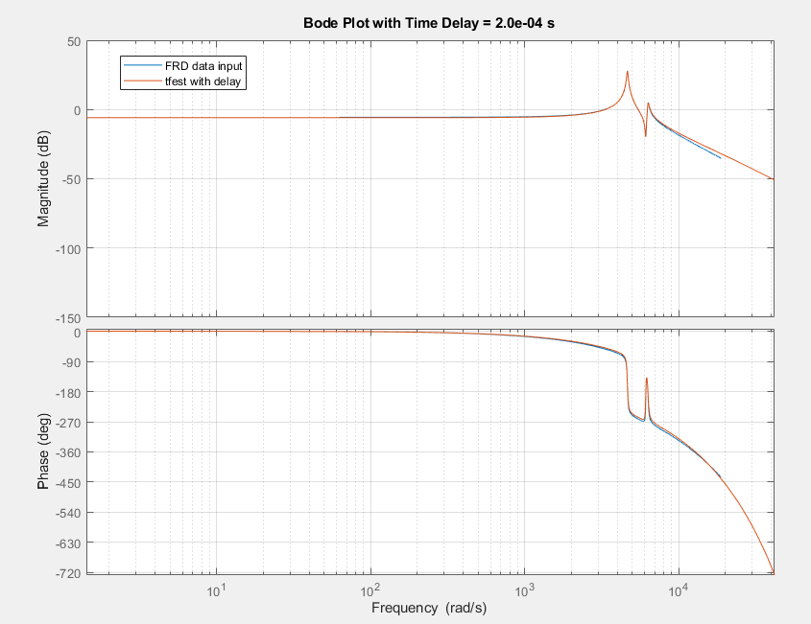

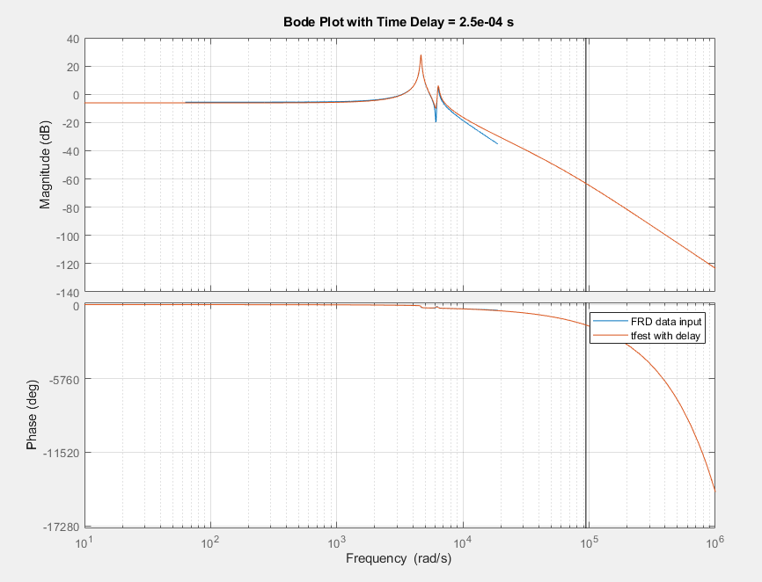

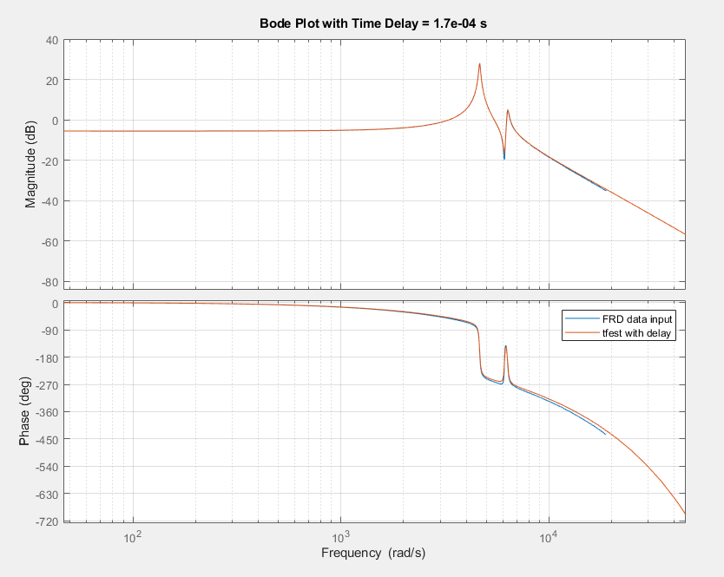

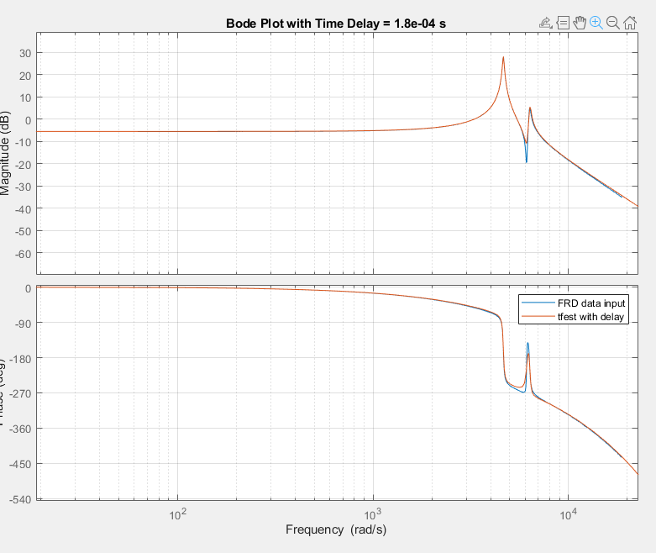

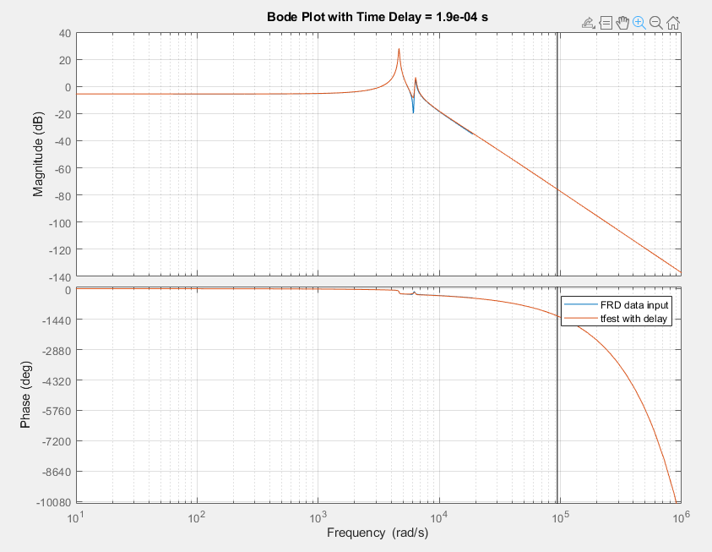

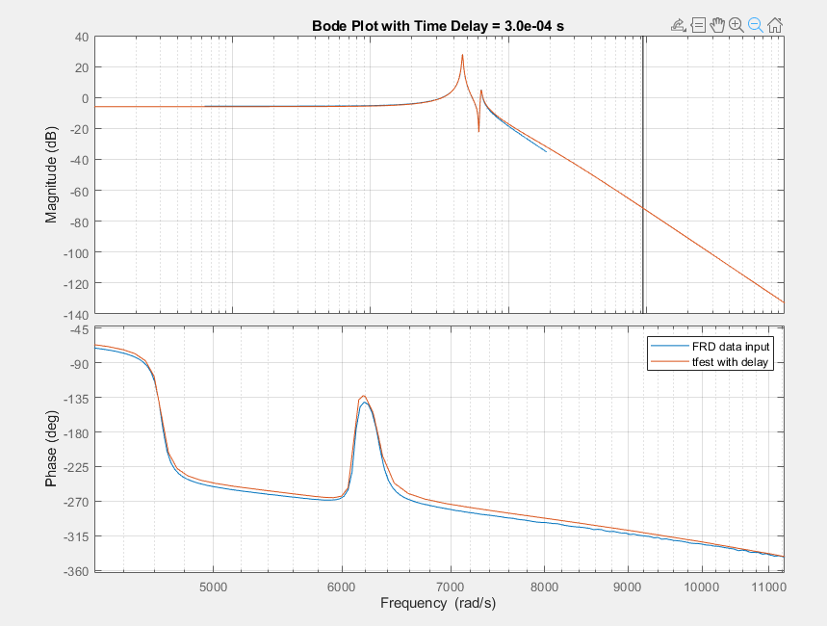

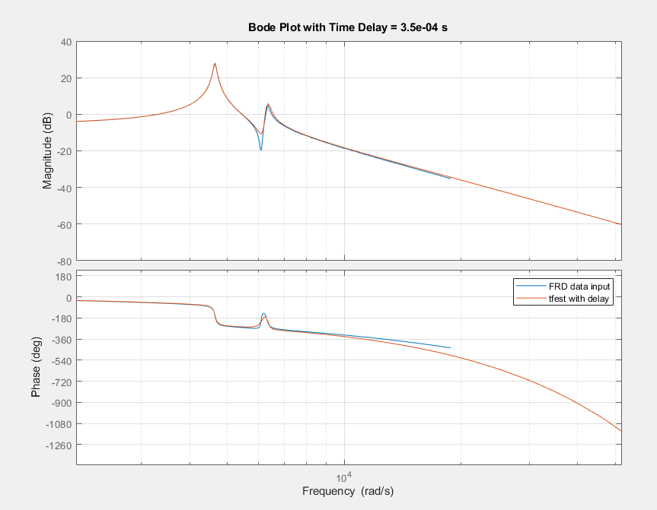

# Good Stuff

### Tfest with Chirp

Iodelay = 2e-4



### Tfest with White noise, no windowing

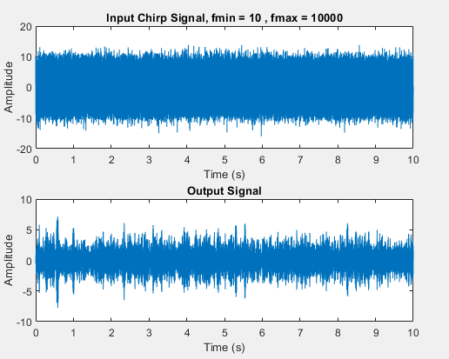

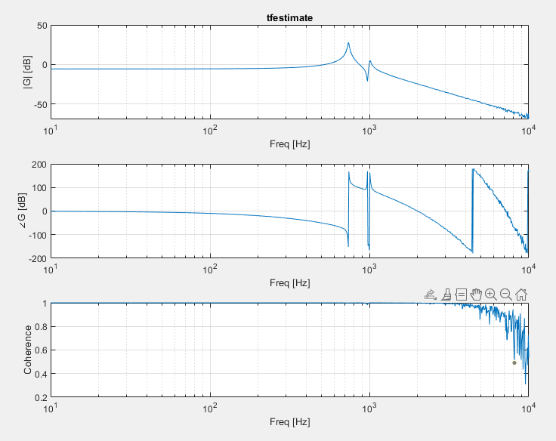

Tfest 2e-4

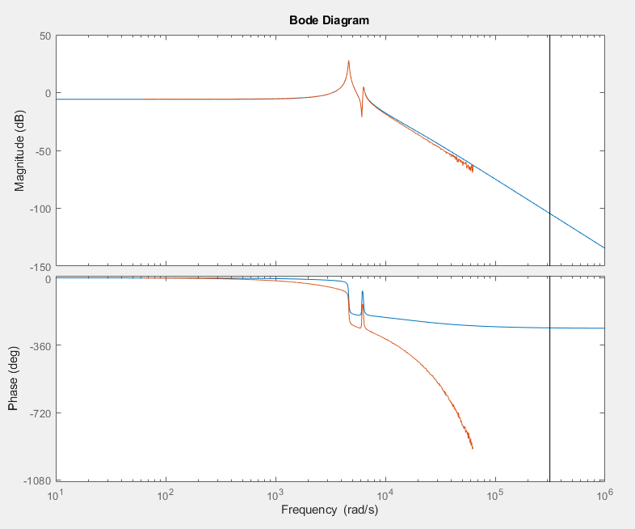

Same thing

#### With windowing

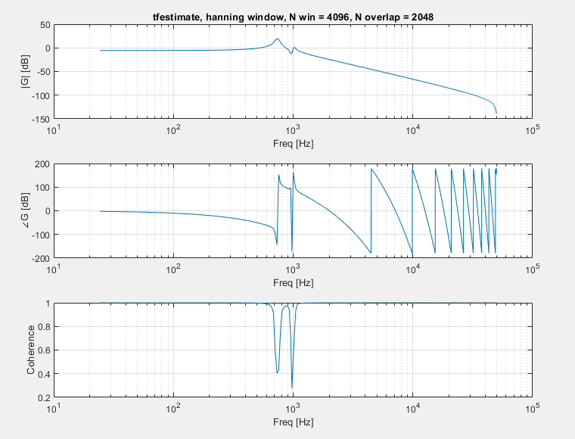

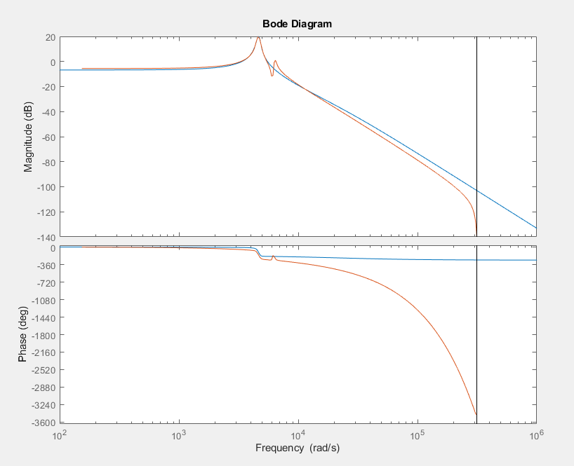

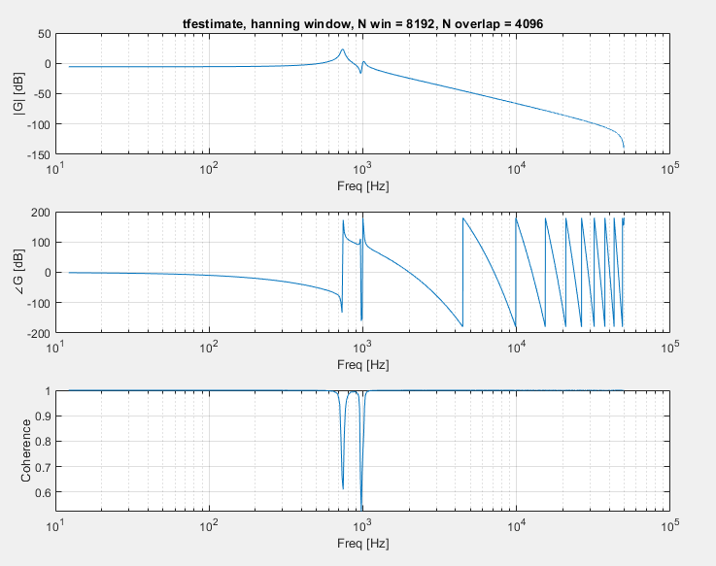

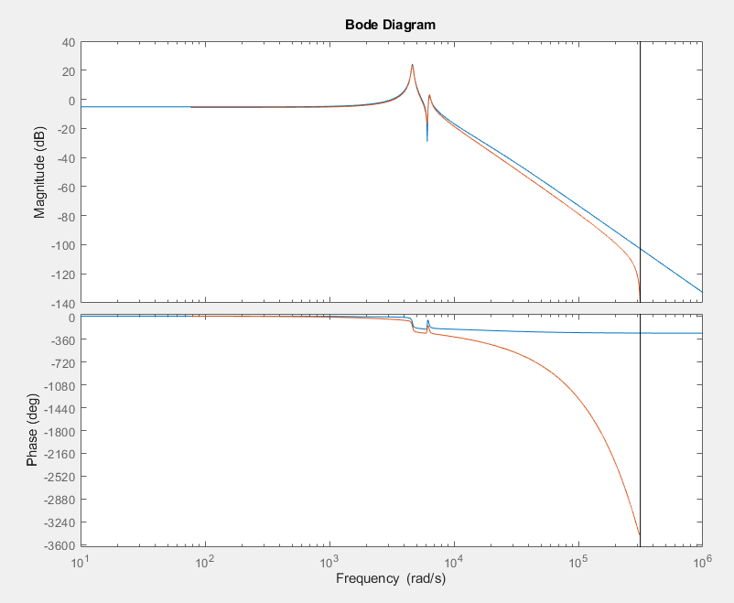

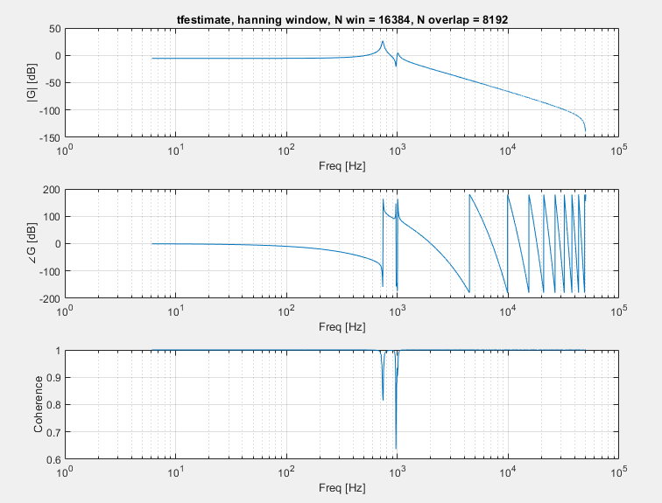

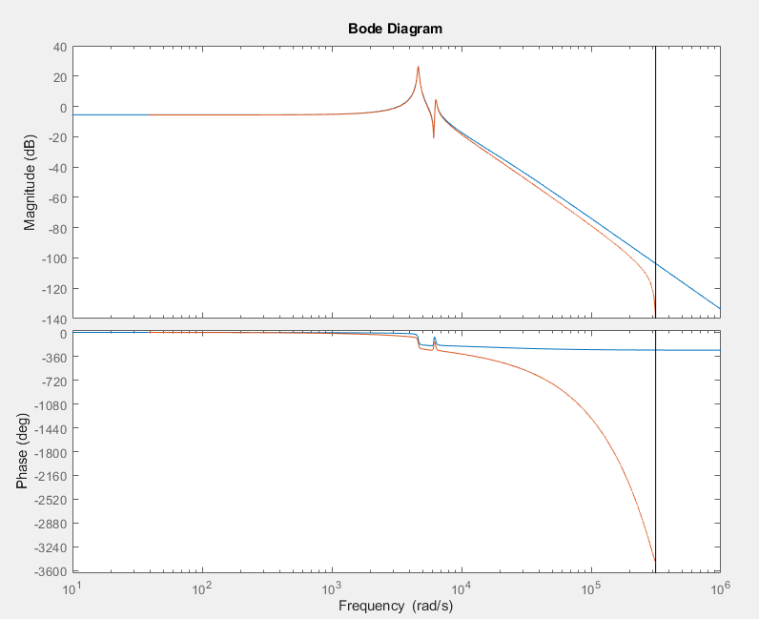

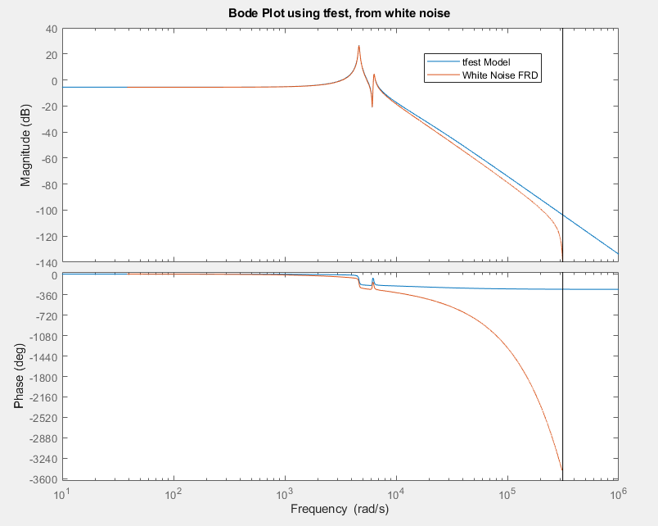

# Questions for Jesse

* Amplitude increasing at high freq?
* Taking multiple chirps and then averaging?
* What windowing

Things to do

* Try Jesse’s python settings and seeing if diff results
  + 120s long chirp signal, 10 to 5e3, ts = 30us